The S A T®
Assistive Technology Compatible Test Form

Practice Test 6

Answers and explanations for section 4, Math Test—Calculator

Explanation for question 1.
Correct answer
Choice A is correct. The given expression 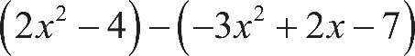 open parenthesis, 2 x squared, minus 4, close parenthesis, minus, open parenthesis, negative 3, x squared, plus 2 x, minus 7, close parenthesis can be rewritten as 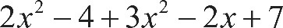 2 x squared, minus 4, plus 3 x squared, minus 2 x, plus 7. Combining like terms yields 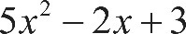 5 x squared, minus 2 x, plus 3.
Incorrect answer
Choices B, C, and D are incorrect and may be the result of errors when applying the distributive property.

Explanation for question 2.
Correct answer
Choice C is correct. The lines shown on the graph give the positions of Paul and Mark during the race. At the start of the race, 0 seconds have elapsed. The y-intercepts of these lines represent the positions at the start of the race, or when 0 seconds have elapsed. The y-intercept of the line that represents Paul’s position during the race is at 0. The y-intercept of the line that represents Mark’s position during the race represents the number of yards Mark was from Paul’s position (at 0 yards) at the start of the race. Because the y-intercept of the line that represents Mark’s position is at the grid line that is halfway between 12 and 24, the value of the y-intercept is 18, and therefore Mark had a head start of 18 yards.
Incorrect answer
Choices A, B, and D are incorrect. The y-intercept of the line that represents Mark’s position shows that he was 18 yards from Paul’s position at the start of the race, so he did not have a head start of 3, 12, or 24 yards.

Explanation for question 3.
Correct answer
Choice A is correct. The leftmost segment in choice A, which represents the first time period, shows that the snow accumulated at a certain rate; the middle segment, which represents the second time period, is horizontal, showing that the snow stopped accumulating; and the rightmost segment, which represents the third time period, is steeper than the first segment, indicating that the snow accumulated at a faster rate than it did during the first time period.
Incorrect answer
Choice B is incorrect. This graph shows snow accumulating faster during the first time period than during the third time period; however, the question says that the rate of snow accumulation in the third time period is higher than in the first time period. Choice C is incorrect. This graph shows snow accumulation increasing during the first time period, not accumulating during the second time period, and then decreasing during the third time period; however, the question says that no snow melted (accumulation did not decrease) during this time. Choice D is incorrect. This graph shows snow accumulating at a constant rate, not stopping for a period of time or accumulating at a faster rate during a third time period.

Explanation for question 4.
Correct answer
Choice D is correct. The equation 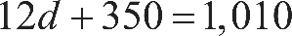 12 d, plus 350, equals 1,010 can be used to determine d, the number of dollars charged per month for the first 12 months. Subtracting 350 from both sides of this equation yields 12 d, equals 660, and then dividing both sides of the equation by 12 yields d equals 55.
Incorrect answer
Choice A is incorrect. If d were equal to 25, the first 12 months would cost 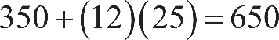 350 plus, 12 times 25, equals 650 dollars, not $1,010. Choice B is incorrect. If d were equal to 35, the first 12 months would cost 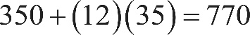 350 plus, 12 times 35, equals 770 dollars, not $1,010. Choice C is incorrect. If d were equal to 45, the first 12 months would cost 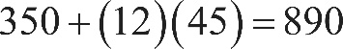 350 plus, 12 times 45, equals 890 dollars, not $1,010.

Explanation for question 5.
Correct answer
Choice B is correct. Both sides of the given inequality can be divided by 3 to yield 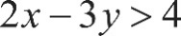 2 x minus 3 y, is greater than 4.
Incorrect answer
Choices A, C, and D are incorrect because they are not equivalent to (do not have the same solution set as) the given inequality. For example, the ordered pair 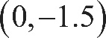 0 comma negative 1.5 is a solution to the given inequality, but it is not a solution to any of the inequalities in choices A, C, or D.

Explanation for question 6.
Correct answer
Choice C is correct. According to the table, 63% of survey respondents get most of their medical information from a doctor and 13% get most of their medical information from the Internet. Therefore, 76% of the 1,200 survey respondents get their information from either a doctor or the Internet, and 76% of 1,200 is 912.
Incorrect answer
Choices A, B, and D are incorrect. According to the table, 76% of survey respondents get their information from either a doctor or the Internet. Choice A is incorrect because 865 is about 72% (the percent of survey respondents who get most of their medical information from a doctor or from magazines/brochures), not 76%, of 1,200. Choice B is incorrect because 887 is about 74%, not 76%, of 1,200. Choice D is incorrect because 926 is about 77%, not 76%, of 1,200.

Explanation for question 7.
Correct answer
Choice D is correct. The members of the city council wanted to assess opinions of all city residents. To gather an unbiased sample, the council should have used a random sampling design to select subjects from all city residents. The given survey introduced a sampling bias because the 500 city residents surveyed were all dog owners. This sample is not representative of all city residents because not all city residents are dog owners.
Incorrect answer
Choice A is incorrect because when the sampling method isn’t random, there is no guarantee that the survey results will be reliable; hence, they cannot be generalized to the entire population. Choice B is incorrect because a larger sample of residents who are dog owners would not correct the sampling bias. Choice C is incorrect because a survey sample of entirely non–dog owners would likely have a biased opinion, just as a sample of dog owners would likely have a biased opinion.

Explanation for question 8.
Correct answer
Choice D is correct. According to the table, 13 people chose vanilla ice cream. Of those people, 8 chose hot fudge as a topping. Therefore, of the people who chose vanilla ice cream, the fraction who chose hot fudge as a topping is 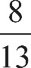 8 over 13.
Incorrect answer
Choice A is incorrect because it represents the fraction of people at the party who chose hot fudge as a topping and vanilla ice cream. Choice B is incorrect because it represents the fraction of people at the party who chose caramel as a topping and vanilla ice cream. Choice C is incorrect because it represents the fraction of people at the party who chose vanilla ice cream.

Explanation for question 9.
Correct answer
Choice B is correct. The land area of the coastal city can be found by subtracting the area of the water from the total area of the coastal city; that is, 92.1, minus 11.3, equals 80.8 square miles. The population density is the population divided by the land area, or 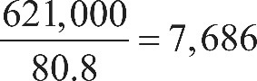 the fraction 621,000 over 80.8, end fraction, equals 7,686, which is closest to 7,690 people per square mile.
Incorrect answer
Choice A is incorrect and may be the result of dividing the population by the total area, instead of the land area. Choice C is incorrect and may be the result of dividing the population by the area of water. Choice D is incorrect and may be the result of making a computational error with the decimal place.

Explanation for question 10.
Correct answer
Choice B is correct. Let x represent the number of days the second voyage lasted. The number of days the first voyage lasted is then x plus 43. Since the two voyages combined lasted a total of 1,003 days, the equation 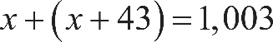 x plus, open parenthesis, x plus 43, close parenthesis, equals 1,003 must hold. Combining like terms yields 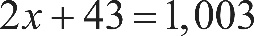 2 x plus 43, equals 1,003, and solving for x gives x equals 480.
Incorrect answer
Choice A is incorrect because 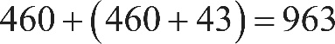 460 plus, open parenthesis, 460 plus 43, close parenthesis, equals 963, not 1,003, days.
Choice C is incorrect because 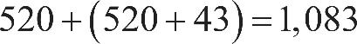 520 plus, open parenthesis, 520 plus 43, close parenthesis, equals 1,083, not 1,003, days.
Choice D is incorrect because 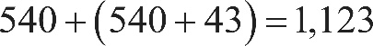 540 plus, open parenthesis, 540 plus 43, close parenthesis, equals 1,123, not 1,003, days.

Explanation for question 11.
Correct answer
Choice B is correct. One way to solve the system of equations is using the method of elimination. Adding the equations as follows eliminates y:
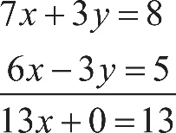 the equation 7 x plus 3 y, equals 8, plus the equation 6 x minus 3 y, equals 5, results in the equation 13 x plus 0, equals 13.
Solving the obtained equation for x gives x equals 1. Substituting 1 for x in the first equation gives 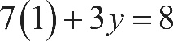 7 times 1, plus 3 y, equals 8. Subtracting 7 from both sides of the equation yields 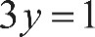 3 y equals 1, so 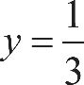 y equals one third. Therefore, the value of x minus y is 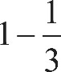 1 minus one third, or two thirds.
Incorrect answer
Choice C is incorrect because 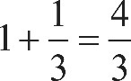 1 plus one third, equals four thirds is the value of x plus y, not x minus y. Choices A and D are incorrect and may be the result of some computational errors.

Explanation for question 12.
Correct answer
Choice D is correct. The average growth rate of the sunflower over a certain time period is the increase in height of the sunflower over the time period divided by the change in time. Symbolically, this rate is 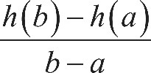 the fraction with numerator h of b, minus h of a, and denominator b minus a, end fraction, where a and b are the first and the last day of the time period, respectively, and 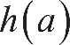 h of a and 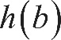 h of b are the heights at the beginning and end of the time period, respectively. Since the time period for each option is the same (21 days), the total growth over the period can be used to evaluate in which time period the sunflower grew the least. According to the graph, the 21-day time period during which the sunflower grew the least over the period was from day 63 to day 84. Therefore, the sunflower’s average growth rate was the least from day 63 to day 84.

Alternate approach: The average growth rate of the sunflower over a certain time period is the slope of the line segment that joins the point on the graph at the beginning of the time period with the point on the graph at the end of the time period. Based on the graph, of the four time periods, the slope of the line segment is least between the sunflower’s height on day 63 and its height on day 84.
Incorrect answer
Choices A, B, and C are incorrect. On the graph, the line segment from day 63 to 84 is less steep than each of the three other line segments representing other periods. Therefore, the average growth rate of the sunflower is the least from day 63 to 84.

Explanation for question 13.
Correct answer
Choice A is correct. Based on the definition and contextual interpretation of the function h, when the value of t increases by 1, the height of the sunflower increases by a centimeters. Therefore, a represents the predicted number of centimeters the sunflower grows each day during the period the function models.
Incorrect answer
Choice B is incorrect. In the given model, the beginning of the period corresponds to t equals 0, and since 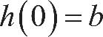 h of 0, equals b, the predicted height, in centimeters, of the sunflower at the beginning of the period is represented by b, not by a. Choice C is incorrect. If the period of time modeled by the function is c days long, then the predicted height, in centimeters, of the sunflower at the end of the period is represented by a, c plus b, not by a. Choice D is incorrect. If the period of time modeled by the function is c days long, the predicted total increase in the height of the sunflower, in centimeters, during that period is represented by the difference h of c, minus h of 0, equals, open parenthesis, a, c plus b, close parenthesis, minus, open parenthesis, a, times 0, plus b, close parenthesis, which is equivalent to a c, not a.

Explanation for question 14.
Correct answer
Choice B is correct. According to the table, the height of the sunflower is 36.36 centimeters on day 14 and 131.00 centimeters on day 35. Since the height of the sunflower between day 14 and day 35 changes at a nearly constant rate, the height of the sunflower increases by approximately 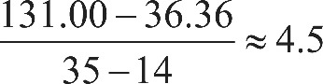 the fraction with numerator 131.00 minus 36.36, and denominator 35 minus 14, end fraction, is approximately equal to 4.5 centimeters per day. Therefore, the equation that models the height of the sunflower t days after it begins to grow is of the form h equals, 4.5 t, plus b. Any ordered pair 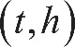 t comma h from the table between day 14 and day 35 can be used to estimate the value of b. For example, substituting the ordered pair 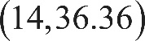 14 comma 36.36 for the ordered pair t comma h into the equation h equals, 4.5 t, plus b gives 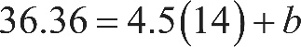 36.36 equals, 4.5 times 14, plus b. Solving this for b yields b equals negative 26.64. Therefore, of the given choices, the equation h equals, 4.5 t minus 27 best models the height h, in centimeters, of the sunflower t days after it begins to grow.
Incorrect answer
Choices A, C, and D are incorrect because the growth rates of the sunflower from day 14 to day 35 in these choices are significantly higher or lower than the true growth rate of the sunflower as shown in the graph or the table. These choices may result from considering time periods different from the period indicated in the question or from calculation errors.

Explanation for question 15.
Correct answer
Choice D is correct. According to the table, the value of y increases by 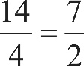 the fraction 14 over 4, equals the fraction 7 over 2 every time the value of x increases by 1. It follows that the simplest equation relating y to x is linear and of the form 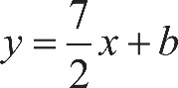 y equals, seven halves x, plus b for some constant b. Furthermore, the ordered pair 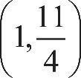 1 comma the fraction 11 over 4 from the table must satisfy this equation. Substituting 1 for x and the fraction 11 over 4 for y in the equation y equals, seven halves x, plus b gives 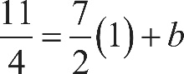 the fraction 11 over 4 equals, seven halves times 1, plus b. Solving this equation for b gives 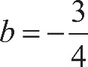 b equals, negative three fourths. Therefore, the equation in choice D correctly relates y to x.
Incorrect answer
Choices A and B are incorrect. The relationship between x and y cannot be exponential because the differences, not the ratios, of y-values are the same every time the x-values change by the same amount. Choice C is incorrect because the ordered pair 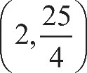 2 comma the fraction 25 over 4 is not a solution to the equation 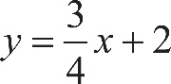 y equals, three fourths x, plus 2. Substituting 2 for x and 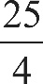 the fraction 25 over 4 for y in this equation gives 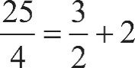 the fraction 25 over 4 equals, three halves plus 2, which is false.

Explanation for question 16.
Correct answer
Choice B is correct. In right triangle A B C, the measure of angle B must be 58 degrees because the sum of the measure of angle A, which is 32 degrees, and the measure of angle B is 90 degrees. Angle D in the right triangle D E F has measure 58 degrees. Hence, triangles A B C and D E F are similar (by angle-angle similarity). Since side B C is the side opposite to the angle with measure 32 degrees and A B is the hypotenuse in right triangle A B C, the ratio 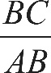 the length of side B C over the length of side A B is equal to 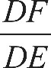 the length of side D F over the length of side D E.

Alternate approach: The trigonometric ratios can be used to answer this question. In right triangle A B C, the ratio 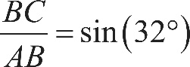 the length of side B C over the length of side A B equals, the sine of 32 degrees. The angle E in triangle D E F has measure X 32 degrees because 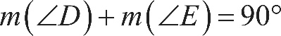 the measure of angle D, plus the measure of angle E, equals 90 degrees. In triangle D E F, the ratio 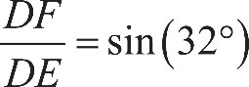 the length of side D F over the length of side D E, equals the sine of 32 degrees. Therefore, 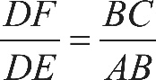 the length of side D F over the length of side D E, equals, the length of side B C over the length of side A B.
Incorrect answer
Choice A is incorrect because 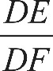 the length of side D F over the length of side D E is the reciprocal of the ratio the length of side B C over the length of side A B. Choice C is incorrect because 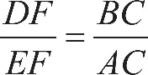 the length of side D F over the length of side D E, equals the length of side B C over the length of side A C, not the length of side B C over the length of side A B. Choice D is incorrect because 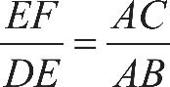 the length of side E F over the length of side D E, equals, the length of side A C over the length of side A B, not the length of side B C over the length of side A B.

Explanation for question 17.
Correct answer
Choice B is correct. Isolating the term that contains the riser height, h, in the formula 2 h plus d, equals 25 gives 2 h equals, 25 minus d. Dividing both sides of this equation by 2 yields 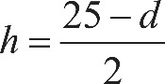 h equals, the fraction with numerator, 25 minus d, and denominator 2, or 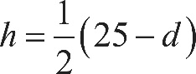 h equals, one half times, open parenthesis, 25 minus d, close parenthesis.
Incorrect answer
Choices A, C, and D are incorrect and may result from incorrect transformations of the riser-tread formula 2 h plus d, equals 25 when expressing h in terms of d.

Explanation for question 18.
Correct answer
Choice C is correct. Since the tread depth, d, must be at least 9 inches, and the riser height, h, must be at least 5 inches, it follows that d is greater than or equal to 9 and h is greater than or equal to 5, respectively. Solving for d in the riser-tread formula 2 h plus d, equals 25 gives d equals, 25 minus 2 h. Thus the first inequality, d is greater than or equal to 9, is equivalent to 25 minus 2 h, is greater than or equal to 9. This inequality can be solved for h as follows:

negative 2 h is greater than or equal to, 9 minus 25
2 h is less than or equal to, 25 minus 9
a 2 h is less than or equal to 16
a h is less than or equal to 8

Therefore, the inequality 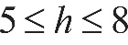 5 is less than or equal to h, which is less than or equal to 8, derived from combining the inequalities h is greater than or equal to 5 and h is less than or equal to 8, represents the set of all possible values for the riser height that meets the code requirement.
Incorrect answer
Choice A is incorrect because the riser height, h, cannot be less than 5 inches because the question states that the riser height must be at least, not at most, 5 inches. Choices B and D are incorrect because the riser height, h, cannot be greater than 8. For example, if h equals 10, then according to the riser-tread formula 2 h plus d, equals 25, it follows that d equals 5 inches. However, d must be at least 9 inches according to the building codes, so h cannot be 10.

Explanation for question 19.
Correct answer
Choice C is correct. Let h be the riser height, in inches, and n be the number of the steps in the stairway. According to the architect’s design, the total rise of the stairway is 9 feet, or 9 times 12, equals 108 inches. Hence, n h equals 108, and solving for n gives 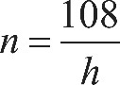 n equals, 108 over h. It is given that 7 is less than h, which is less than 8. It follows that 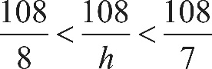 108 over 8, is less than 108 over h, which is less than 108 over 7, or equivalently, 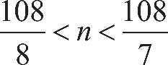 108 over 8, is less than n, which is less than 108 over 7. Since 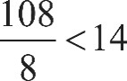 108 over 8, is less than 14 and 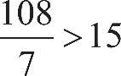 108 over 7, is greater than 15 and n is an integer, it follows that 14 is less than or equal to n, which is less than or equal to 15. Since n can be an odd number, n can only be 15; therefore, 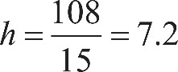 h equals, 108 over 15, which equals 7.2 inches. Substituting 7.2 for h in the riser-tread formula 2 h plus d, equals 25 gives 14.4 plus d, equals 25. Solving for d gives d equals 10.6 inches.
Incorrect answer
Choice A is incorrect because 7.2 inches is the riser height, not the tread depth of the stairs. Choice B is incorrect and may be the result of calculation errors. Choice D is incorrect because 15 is the number of steps, not the tread depth of the stairs.

Explanation for question 20.
Correct answer
Choice C is correct. Since the product of x minus 6 and x plus 0.7 equals 0, by the zero product property either x minus 6, equals 0 or x plus 0.7, equals 0. Therefore, the solutions to the equation are 6 and negative 0.7. The sum of 6 and negative 0.7 is 5.3.
Incorrect answer
Choice A is incorrect and is the result of subtracting 6 from negative 0.7 instead of adding. Choice B is incorrect and may be the result of erroneously calculating the sum of negative 6 and 0.7 instead of 6 and negative 0.7. Choice D is incorrect and is the sum of 6 and 0.7, not 6 and negative 0.7.

Explanation for question 21.
Correct answer
Choice D is correct. The sample of 150 largemouth bass was selected at random from all the largemouth bass in the pond, and since 30% of the fish in the sample weighed more than 2 pounds, it can be concluded that approximately 30% of all largemouth bass in the pond weigh more than 2 pounds.
Incorrect answer
Choices A, B, and C are incorrect. Since the sample contained 150 largemouth bass, of which 30% weighed more than 2 pounds, this result can be generalized only to largemouth bass in the pond, not to all fish in the pond.

Explanation for question 22.
Correct answer
Choice B is correct. The median of a list of numbers is the middle value when the numbers are listed in order from least to greatest. For the electoral votes shown in the table, their frequency should also be taken into account. Since there are 21 states represented in the table, the middle number will be the eleventh number in the ordered list. Counting the frequencies from the top of the table 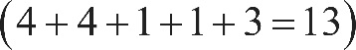 open parenthesis, 4 plus 4, plus 1, plus 1, plus 3, equals 13, close parenthesis shows that the median number of electoral votes for the 21 states is 15.
Incorrect answer
Choice A is incorrect. If the electoral votes are ordered from least to greatest taking into account the frequency, 13 will be in the tenth position, not the middle. Choice C is incorrect because 17 is in the fourteenth position, not in the middle, of the ordered list. Choice D is incorrect because 20 is in the fifteenth position, not in the middle, of the ordered list.

Explanation for question 23.
Correct answer
Choice C is correct. Since the graph shows the height of the ball above the ground after it was dropped, the number of times the ball was at a height of 2 feet is equal to the number of times the graph crosses the horizontal grid line that corresponds to a height of 2 feet. The graph crosses this grid line three times.
Incorrect answer
Choices A, B, and D are incorrect. According to the graph, the ball was at a height of 2 feet three times, not one, two, or four times.

Explanation for question 24.
Correct answer
Choice D is correct. To find the percent increase of the customer’s water bill, the absolute increase of the bill, in dollars, is divided by the original amount of the bill, and the result is multiplied by 100%, as follows: 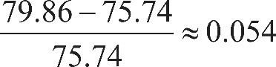 the fraction with numerator 79.86 minus 75.74, and denominator 75.74, is approximately equal to, 0.054; 0.054 times 100 percent, equals 5.4 percent.
Incorrect answer
Choice A is incorrect. This choice is the difference 79.86, minus 75.74 rounded to the nearest tenth, which is the (absolute) increase of the bill’s amount, not its percent increase. Choice B is incorrect and may be the result of some calculation errors. Choice C is incorrect and is the result of dividing the difference between the two bill amounts by the new bill amount instead of the original bill amount.

Explanation for question 25.
Correct answer
Choice B is correct. A linear function has a constant rate of change, and any two rows of the table shown can be used to calculate this rate. From the first row to the second, the value of x is increased by 2 and the value of 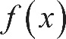 f of x is increased by 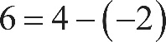 6 equals, 4 minus negative 2. So the values of f of x increase by 3 for every increase by 1 in the value of x. Since 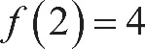 f of 2, equals 4, it follows that 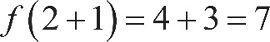 f of, open parenthesis, 2 plus 1, close parenthesis, equals, 4 plus 3, which equals 7. Therefore, 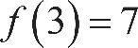 f of 3, equals 7.
Incorrect answer
Choice A is incorrect. This is the third x-value in the table, not 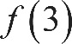 f of 3. Choices C and D are incorrect and may result from errors when calculating the function’s rate of change.

Explanation for question 26.
Correct answer
Choice C is correct. Since Gear A has 20 teeth and Gear B has 60 teeth, the gear ratio for Gears A and B is 20 to 60. Thus the ratio of the number of revolutions per minute for the two gears is 60 to 20, or 3 to 1. That is, when Gear A turns at 3 revolutions per minute, Gear B turns at 1 revolution per minute. Similarly, since Gear B has 60 teeth and Gear C has 10 teeth, the gear ratio for Gears B and C is 60 to 10, and the ratio of the revolutions per minute for the two gears is 10 to 60, or 1 to 6. That is, when Gear B turns at 1 revolution per minute, Gear C turns at 6 revolutions per minute. Therefore, if Gear A turns at 100 revolutions per minute, then Gear B turns at 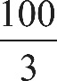 the fraction 100 over 3, revolutions per minute, and Gear C turns at 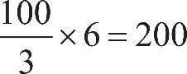 the fraction 100 over 3, end fraction, times 6, equals 200 revolutions per minute.

Alternate approach: Gear A and Gear C can be considered as directly connected since their “contact” speeds are the same. Gear A has twice as many teeth as Gear C, and since the ratios of the number of teeth are equal to the reverse of the ratios of rotation speeds, in revolutions per minute, Gear C would be rotated at a rate that is twice the rate of Gear A. Therefore, Gear C will be rotated at a rate of 200 revolutions per minute since Gear A is rotated at 100 revolutions per minute.
Incorrect answer
Choice A is incorrect and may result from using the gear ratio instead of the ratio of the revolutions per minute when calculating the rotational speed of Gear C. Choice B is incorrect and may result from comparing the revolutions per minute of the gears using addition instead of multiplication. Choice D is incorrect and may be the result of multiplying the 100 revolutions per minute for Gear A by the number of teeth in Gear C.

Explanation for question 27.
Correct answer
Choice A is correct. One way to find the radius of the circle is to rewrite the given equation in standard form, 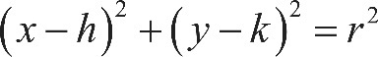 open parenthesis, x minus h, close parenthesis, squared, plus, open parenthesis, y minus k, close parenthesis, squared, equals r squared, where 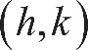 the ordered pair h comma k is the center of the circle and the radius of the circle is r. To do this, divide the original equation, 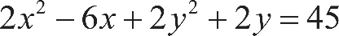 2 x squared, minus 6 x, plus 2 y squared, plus 2 y, equals 45, by 2 to make the leading coefficients of 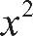 x squared and 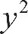 y squared each equal to 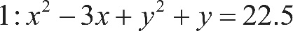 1 as follows: x squared, minus 3 x, plus y squared, plus y, equals 22.5. Then complete the square to put the equation in standard form. To do so, first rewrite 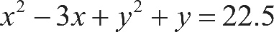 x squared, minus 3 x, plus y squared, plus y, equals 22.5 as open parenthesis, x squared, minus 3 x, plus 2.25, close parenthesis, minus 2.25, plus, open parenthesis, y squared, plus y, plus 0.25, close parenthesis, minus 0.25, equals 22.5. Second, add 2.25 and 0.25 to both sides of the equation: open parenthesis, x squared, minus 3 x, plus 2.25, close parenthesis, plus, open parenthesis, y squared, plus y, plus 0.25, close parenthesis, equals 25. Since 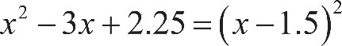 x squared, minus 3 x, plus 2.25, equals, open parenthesis, x minus 1.5, close parenthesis, squared, 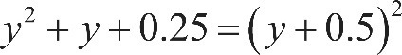 y squared, plus y, plus 0.25, equals, open parenthesis, y plus 0.5, close parenthesis, squared and 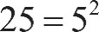 25 equals 5 squared, it follows that 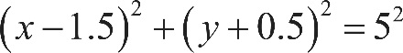 open parenthesis, x minus 1.5, close parenthesis, squared, plus, open parenthesis, y plus 0.5, close parenthesis, squared, equals 5 squared. Therefore, the radius of the circle is 5.
Incorrect answer
Choices B, C, and D are incorrect and may be the result of errors in manipulating the equation or of a misconception about the standard form of the equation of a circle in the x y-plane.

Explanation for question 28.
Correct answer
Choice A is correct. The coordinates of the points at a distance d units from the point with coordinate a on the number line are the solutions to the equation 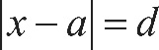 the absolute value of x minus a, end absolute value, equals d. Therefore, the coordinates of the points at a distance of 3 units from the point with coordinate negative 4 on the number line are the solutions to the equation 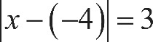 the absolute value of x minus negative 4, end absolute value, equals 3, which is equivalent to 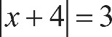 the absolute value of x plus 4, end absolute value, equals 3.
Incorrect answer
Choice B is incorrect. The solutions of 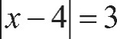 the absolute value of x minus 4, end absolute value, equals 3 are the coordinates of the points on the number line at a distance of 3 units from the point with coordinate 4. Choice C is incorrect. The solutions of 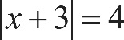 the absolute value of x plus 3, end absolute value, equals 4 are the coordinates of the points on the number line at a distance of 4 units from the point with coordinate negative 3. Choice D is incorrect. The solutions of 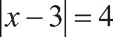 the absolute value of x minus 3, end absolute value, equals 4 are the coordinates of the points on the number line at a distance of 4 units from the point with coordinate 3.

Explanation for question 29.
Correct answer
Choice B is correct. The average speed of the model car is found by dividing the total distance traveled by the car by the total time the car traveled. In the first t seconds after the car starts, the time changes from 0 to t seconds. So the total distance the car traveled is the distance it traveled at t seconds minus the distance it traveled at 0 seconds. At 0 seconds, the car has traveled 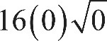 16 times 0, times the square root of 0 inches, which is equal to 0 inches. According to the equation given, after t seconds, the car has traveled 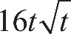 16 t, times the square root of t inches. In other words, after the car starts, it travels a total of 16 t, times the square root of t inches in t seconds. Dividing this total distance traveled by the total time shows the car’s average speed: 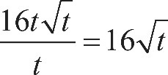 the fraction with numerator 16 t, times the square root of t, and denominator t, equals 16 times the square root of t inches per second.
Incorrect answer
Choices A, C, and D are incorrect and may result from misconceptions about how average speed is calculated.

Explanation for question 30.
Correct answer
Choice D is correct. The data in the scatterplot roughly fall in the shape of a downward-opening parabola; therefore, the coefficient for the x squared term must be negative. Based on the location of the data points, the y-intercept of the parabola should be somewhere between 740 and 760. Therefore, of the equations given, the best model is y equals, negative 1.674, x squared, plus 19.76 x, plus 745.73.
Incorrect answer
Choices A and C are incorrect. The positive coefficient of the x squared term means that these equations each define upward-opening parabolas, whereas a parabola that fits the data in the scatterplot must open downward. Choice B is incorrect because it defines a parabola with a y-intercept that has a negative y-coordinate, whereas a parabola that fits the data in the scatterplot must have a y-intercept with a positive y-coordinate.

Explanation for question 31.
Correct answer
The correct answer is 10. Let n be the number of friends originally in the group. Since the cost of the trip was $800, the share, in dollars, for each friend was originally 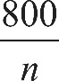 the fraction with numerator 800 and denominator n. When two friends decided not to go on the trip, the number of friends who split the $800 cost became, n minus 2 and each friend’s cost became 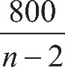 the fraction with numerator 800, and denominator n minus 2. Since this share represented a $20 increase over the original share, the equation 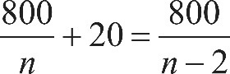 the fraction with numerator 800 and denominator n, end fraction, plus 20, equals the fraction with numerator 800, and denominator n minus 2, end fraction must be true. Multiplying each side of 800 over n, end fraction, plus 20, equals the fraction with numerator 800, and denominator n minus 2, end fraction by 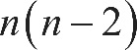 n times, open parenthesis, n minus 2, close parenthesis to clear all the denominators gives 800 times, open parenthesis, n minus 2, close parenthesis, plus, 20 n times, open parenthesis, n minus 2, close parenthesis, equals 800 n

This is a quadratic equation and can be rewritten in the standard form by expanding, simplifying, and then collecting like terms on one side, as shown below:

800 n, minus 1600, plus 20 n squared, minus 40 n, equals 800 n
40 n, minus 80, plus n squared, minus 2 n, equals 40 n
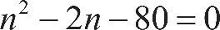 n squared, minus 2 n, minus 80, equals 0

After factoring, this becomes 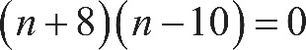 open parenthesis, n plus 8, close parenthesis, times, open parenthesis, n minus 10, close parenthesis, equals 0.

The solutions of this equation are negative 8 and 10. Since a negative solution makes no sense for the number of people in a group, the number of friends originally in the group was 10.

Explanation for question 32.
Correct answer
The correct answer is 31. The equation can be solved using the steps shown below.

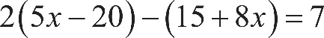 2 times, open parenthesis, 5 x minus 20, close parenthesis, minus, open parenthesis, 15 plus 8 x, close parenthesis, equals 7
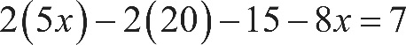 2 times 5 x, minus, 2 times 20, minus 15, minus 8 x, equals 7. Apply the distributive property.
10 x, minus 40, minus 15, minus 8 x, equals 7. Multiply.
2 x minus 55, equals 7. Combine like terms.
2 x equals 62. Add 55 to both sides of the equation.
x equals 31. Divide both sides of the equation by 2.

Explanation for question 33.
Correct answer
The possible correct answers are 97, 98, 99, 100, and 101. The volume of a cylinder can be found by using the formula 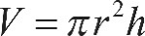 V equals, pi, r squared, times h, where r is the radius of the circular base and h is the height of the cylinder. The smallest possible volume, in cubic inches, of a graduated cylinder produced by the laboratory supply company can be found by substituting 2 for r and 7.75 for h, giving 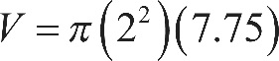 V equals, pi times, open parenthesis, 2 squared, close parenthesis, times 7.75. This gives a volume of approximately 97.39 cubic inches, which rounds to 97 cubic inches. The largest possible volume, in cubic inches, can be found by substituting 2 for r and 8 for h, giving 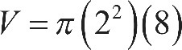 V equals, pi times, open parenthesis, 2 squared, close parenthesis, times 8. This gives a volume of approximately 100.53 cubic inches, which rounds to 101 cubic inches. Therefore, the possible volumes are all the integers greater than or equal to 97 and less than or equal to 101, which are 97, 98, 99, 100, and 101. Any of these numbers may be gridded as the correct answer.

Explanation for question 34.
Correct answer
The correct answer is 5. The intersection points of the graphs of 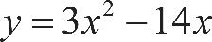 y equals, 3 x squared, minus 14 x and y equals x can be found by solving the system consisting of these two equations. To solve the system, substitute x for y in the first equation. This gives 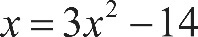 x equals, 3 x squared, minus 14 x. Subtracting x from both sides of the equation gives 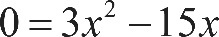 0 equals, 3 x squared, minus 15 x. Factoring 3 x out of each term on the left-hand side of the equation gives 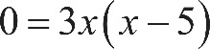 0 equals, 3 x times, open parenthesis, x minus 5, close parenthesis. Therefore, the possible values for x are 0 and 5. Since y equals x, the two intersection points are 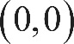 the points with coordinates 0 comma 0 and 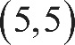 5 comma 5. Therefore, a, equals 5.

Explanation for question 35.
Correct answer
The correct answer is 1.25 or five fourths. The y-coordinate of the x-intercept is 0, so 0 can be substituted for y, giving 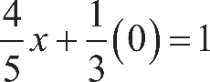 four fifths x, plus one third times 0, equals 1. This simplifies to 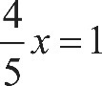 four fifths x, equals 1. Multiplying both sides of four fifths x, equals 1 by 5 gives 4 x equals 5. Dividing both sides of 4 x equals 5 by 4 gives 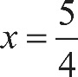 x equals five fourths, which is equivalent to 1.25. Either 5 slash 4 or 1.25 may be gridded as the correct answer.

Explanation for question 36.
Correct answer
The correct answer is 2.6 or 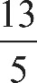 13 over 5. Since the mean of a set of numbers can be found by adding the numbers together and dividing by how many numbers there are in the set, the mean mass, in kilograms, of the rocks Andrew collected is 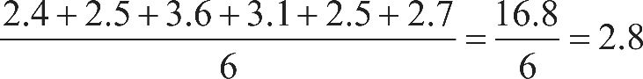 the fraction with numerator 2.4, plus 2.5, plus 3.6, plus 3.1, plus 2.5, plus 2.7, and denominator 6, equals 16.8 over 6, which equals 2.8. Since the mean mass of the rocks Maria collected is 0.1 kilogram greater than the mean mass of rocks Andrew collected, the mean mass of the rocks Maria collected is 2.8, plus 0.1, equals 2.9 kilograms. The value of x can be found by writing an equation for finding the mean: 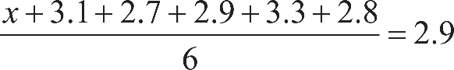 the fraction with numerator x plus 3.1, plus 2.7, plus 2.9, plus 3.3, plus 2.8, and denominator 6, equals 2.9. Solving this equation gives x equals 2.6, which is equivalent to the fraction 13 over 5. Either 2.6 or 13 slash 5 may be gridded as the correct answer.

Explanation for question 37.
Correct answer
The correct answer is 30. The situation can be represented by the equation 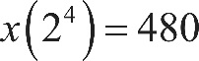 x times, open parenthesis, 2 to the fourth power, close parenthesis, equals 480, where the 2 represents the fact that the amount of money in the account doubled each year and the 4 represents the fact that there are 4 years between January 1, 2001, and January 1, 2005. Simplifying x times, open parenthesis, 2 to the fourth power, close parenthesis, equals 480 gives 16 x equals 480. Therefore, x equals 30.

Explanation for question 38.
Correct answer
The correct answer is 8. The 6 students represent 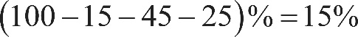 open parenthesis, 100 minus 15, minus 45, minus 25, close parenthesis, percent, equals 15 percent of those invited to join the committee. If x people were invited to join the committee, then 0.15 x, equals 6. Thus, there were 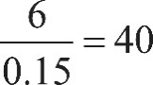 6 over, 0.15, equals 40 people invited to join the committee. It follows that there were 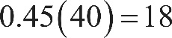 0.45 times 40, equals 18 teachers and 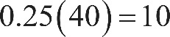 0.25 times 40, equals 10 school and district administrators invited to join the committee. Therefore, there were 8 more teachers than school and district administrators invited to join the committee.

