The S A T®
Practice Test #6

Reading Test
52 Questions

Turn to Section 1 of your answer sheet to answer the questions in this section.

Directions
Each passage or pair of passages in this section is followed by a number of questions. After reading each passage or pair, choose the best answer to each question based on what is stated or implied in the passage or passages and in any accompanying graphics (such as a table or graph).

Questions 1 through 10 are based on the following passage.
This passage is adapted from Daniyal Mueenuddin, “Nawabdin Electrician.” ©2009 by Daniyal Mueenuddin.

Another man might have thrown up his hands—but not Nawabdin. His twelve daughters acted as a spur to his genius, and he looked with satisfaction in the mirror each morning at the face of a warrior going out to do battle. Nawab of course knew that he must proliferate his sources of revenue—the salary he received from K. K. Harouni for tending the tube wells would not even begin to suffice. He set up a little one-room flour mill, run off a condemned electric motor—condemned by him. He tried his hand at fish-farming in a little pond at the edge of his master’s fields. He bought broken radios, fixed them, and resold them. He did not demur even when asked to fix watches, though that enterprise did spectacularly badly, and in fact earned him more kicks than kudos, for no watch he took apart ever kept time again.

K. K. Harouni rarely went to his farms, but lived mostly in Lahore. Whenever the old man visited, Nawab would place himself night and day at the door leading from the servants’ sitting area into the walled grove of ancient banyan trees where the old farmhouse stood. Grizzled, his peculiar aviator glasses bent and smudged, Nawab tended the household machinery, the air conditioners, water heaters, refrigerators, and water pumps, like an engineer tending the boilers on a foundering steamer in an Atlantic gale. By his superhuman efforts he almost managed to maintain K. K. Harouni in the same mechanical cocoon, cooled and bathed and lighted and fed, that the landowner enjoyed in Lahore.

Harouni of course became familiar with this ubiquitous man, who not only accompanied him on his tours of inspection, but morning and night could be found standing on the master bed rewiring the light fixture or in the bathroom poking at the water heater. Finally, one evening at teatime, gauging the psychological moment, Nawab asked if he might say a word. The landowner, who was cheerfully filing his nails in front of a crackling rosewood fire, told him to go ahead.

“Sir, as you know, your lands stretch from here to the Indus, and on these lands are fully seventeen tube wells, and to tend these seventeen tube wells there is but one man, me, your servant. In your service I have earned these gray hairs”—here he bowed his head to show the gray—“and now I cannot fulfill my duties as I should. Enough, sir, enough. I beg you, forgive me my weakness. Better a darkened house and proud hunger within than disgrace in the light of day. Release me, I ask you, I beg you.”

The old man, well accustomed to these sorts of speeches, though not usually this florid, filed away at his nails and waited for the breeze to stop.

“What’s the matter, Nawabdin?”

“Matter, sir? O what could be the matter in your service. I’ve eaten your salt for all my years. But sir, on the bicycle now, with my old legs, and with the many injuries I’ve received when heavy machinery fell on me—I cannot any longer bicycle about like a bridegroom from farm to farm, as I could when I first had the good fortune to enter your employment. I beg you, sir, let me go.”

“And what’s the solution?” asked Harouni, seeing that they had come to the crux. He didn’t particularly care one way or the other, except that it touched on his comfort—a matter of great interest to him.

“Well, sir, if I had a motorcycle, then I could somehow limp along, at least until I train up some younger man.”

The crops that year had been good, Harouni felt expansive in front of the fire, and so, much to the disgust of the farm managers, Nawab received a brand-new motorcycle, a Honda 70. He even managed to extract an allowance for gasoline.

The motorcycle increased his status, gave him weight, so that people began calling him “Uncle,” and asking his opinion on world affairs, about which he knew absolutely nothing. He could now range further, doing a much wider business. Best of all, now he could spend every night with his wife, who had begged to live not on the farm but near her family in Firoza, where also they could educate at least the two eldest daughters. A long straight road ran from the canal headworks near Firoza all the way to the Indus, through the heart of the K. K. Harouni lands. Nawab would fly down this road on his new machine, with bags and cloths hanging from every knob and brace, so that the bike, when he hit a bump, seemed to be flapping numerous small vestigial wings; and with his grinning face, as he rolled up to whichever tube well needed servicing, with his ears almost blown off, he shone with the speed of his arrival.

Question 1.
The main purpose of paragraph 1 is to
A. characterize Nawab as a loving father.
B. outline the schedule of a typical day in Nawab’s life.
C. describe Nawab’s various moneymaking ventures.
D. contrast Nawab’s and Harouni’s lifestyles.

Question 2.
As used in sentence 7 of paragraph 1, the word “kicks” most nearly means
A. thrills.
B. complaints.
C. jolts.
D. interests.

Question 3.
The author uses the image of an engineer at sea (in sentence 3 of paragraph 2) most likely to
A. suggest that Nawab often dreams of having a more exciting profession.
B. highlight the fact that Nawab’s primary job is to tend to Harouni’s tube wells.
C. reinforce the idea that Nawab has had many different occupations in his life.
D. emphasize how demanding Nawab’s work for Harouni is.

Question 4.
Which choice best supports the claim that Nawab performs his duties for Harouni well?
A. Sentence 4 of paragraph 2 (“By his . . . Lahore”)
B. Sentence 3 of paragraph 3 (“The landowner . . . ahead”)
C. Sentence 2 of paragraph 4 (“In your . . . should”)
D. Sentence 3 of paragraph 7 (“I’ve . . . years”)

Question 5.
In the context of the conversation between Nawab and Harouni, Nawab’s comments in paragraph 4 (“Sir . . . beg you”) mainly serve to
A. flatter Harouni by mentioning how vast his lands are.
B. boast to Harouni about how competent and reliable Nawab is.
C. emphasize Nawab’s diligence and loyalty to Harouni.
D. notify Harouni that Nawab intends to quit his job tending the tube wells.

Question 6.
Nawab uses the word “bridegroom” (in sentence 4 of paragraph 7) mainly to emphasize that he’s no longer
A. in love.
B. naive.
C. busy.
D. young.

Question 7.
It can reasonably be inferred from the passage that Harouni provides Nawab with a motorcycle mainly because
A. Harouni appreciates that Nawab has to work hard to support his family.
B. Harouni sees benefit to himself from giving Nawab a motorcycle.
C. Nawab’s speech is the most eloquent that Harouni has ever heard.
D. Nawab threatens to quit if Harouni doesn’t agree to give him a motorcycle.

Question 8.
Which choice provides the best evidence for the answer to question 7?
A. Sentence 1 of paragraph 8 (“And . . . crux”)
B. Sentence 2 of paragraph 8 (“He didn’t . . . him”)
C. Sentence 2 of paragraph 10 (“He even . . . gasoline”)
D. Sentence 2 of paragraph 11 (“He could . . . business”)

Question 9.
The passage states that the farm managers react to Nawab receiving a motorcycle with
A. disgust.
B. happiness.
C. envy.
D. indifference.

Question 10.
According to the passage, what does Nawab consider to be the best result of getting the motorcycle?
A. People start calling him “Uncle.”
B. He’s able to expand his business.
C. He’s able to educate his daughters.
D. He can spend more time with his wife.

Questions 11 through 21 are based on the following passage and supplementary material.
This passage is adapted from Stephen Coleman, Scott Anthony, and David E. Morrison, “Public Trust in the News.” ©2009 by Stephen Coleman.

The news is a form of public knowledge. Unlike personal or private knowledge (such as the health of one’s friends and family; the conduct of a private hobby; a secret liaison), public knowledge increases in value as it is shared by more people. The date of an election and the claims of rival candidates; the causes and consequences of an environmental disaster; a debate about how to frame a particular law; the latest reports from a war zone—these are all examples of public knowledge that people are generally expected to know in order to be considered informed citizens. Thus, in contrast to personal or private knowledge, which is generally left to individuals to pursue or ignore, public knowledge is promoted even to those who might not think it matters to them. In short, the circulation of public knowledge, including the news, is generally regarded as a public good which cannot be solely demand-driven.

The production, circulation, and reception of public knowledge is a complex process. It is generally accepted that public knowledge should be authoritative, but there is not always common agreement about what the public needs to know, who is best placed to relate and explain it, and how authoritative reputations should be determined and evaluated. Historically, newspapers such as The Times and broadcasters such as the B B C were widely regarded as the trusted shapers of authoritative agendas and conventional wisdom. They embodied the Oxford English Dictionary’s definition of authority as the “power over, or title to influence, the opinions of others.” As part of the general process of the transformation of authority whereby there has been a reluctance to uncritically accept traditional sources of public knowledge, the demand has been for all authority to make explicit the frames of value which determine their decisions. Centres of news production, as our focus groups show, have not been exempt from this process. Not surprisingly perhaps some news journalists feel uneasy about this renegotiation of their authority:

Editors are increasingly casting a glance at the “most read” lists on their own and other websites to work out which stories matter to readers and viewers. And now the audience—which used to know its place—is being asked to act as a kind of journalistic ombudsman, ruling on our credibility (broadcast journalist, 2008).

The result of democratising access to TV news could be political disengagement by the majority and a dumbing down through a popularity contest of stories (online news editor, 2007).

Despite the rhetorical bluster of these statements, they amount to more than straightforward professional defensiveness. In their reference to an audience “which used to know its place” and conflation between democratisation and “dumbing down,” they are seeking to argue for a particular mode of public knowledge: one which is shaped by experts, immune from populist pressures; and disseminated to attentive, but mainly passive recipients. It is a view of citizenship that closes down opportunities for popular involvement in the making of public knowledge by reinforcing the professional claims of experts. The journalists quoted above are right to feel uneasy, for there is, at almost every institutional level in contemporary society, scepticism towards the epistemological authority of expert elites. There is a growing feeling, as expressed by several of our focus group participants, that the news media should be “informative rather than authoritative”; the job of journalists should be to “give the news as raw as it is, without putting their slant on it”; and people should be given “sufficient information” from which “we would be able to form opinions of our own.”

At stake here are two distinct conceptions of authority. The journalists we have quoted are resistant to the democratisation of news: the supremacy of the clickstream (according to which editors raise or lower the profile of stories according to the number of readers clicking on them online); the parity of popular culture with “serious” news; the demands of some audience members for raw news rather than constructed narratives.

Note: The following figure supplements this passage.
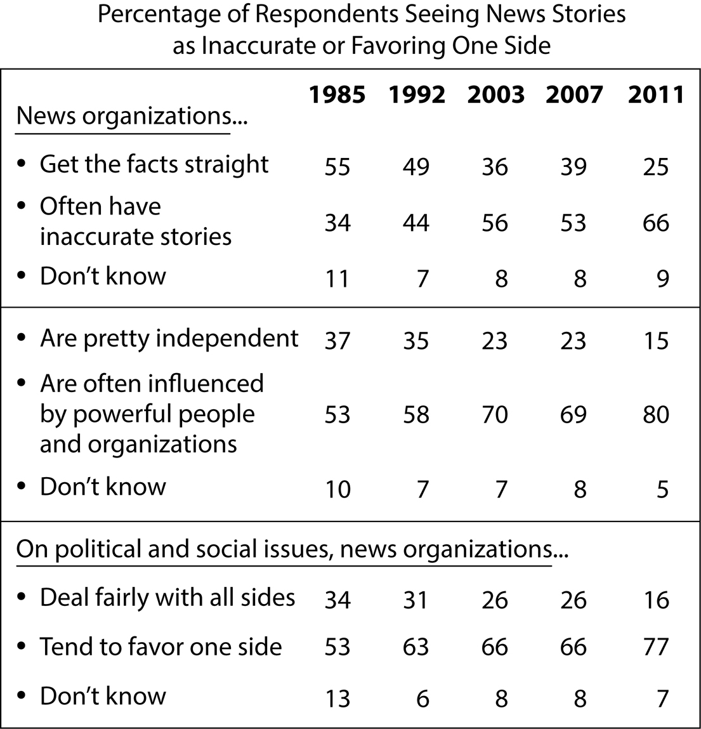
Adapted from “Pew Research Center for the People & the Press Report on Views of the News Media, 1985 through 2011.” ©2011 by Pew Research Center.

Begin skippable figure description.
The figure presents a 6-column table titled, “Percentage of Respondents Seeing News Stories as Inaccurate or Favoring One Side.” There is no heading for column 1. Column 1 contains statements relating to the accuracy and fairness of news organizations. The headings for columns 2 through 6 are as follows: 1985; 1992; 2003; 2007; 2011. The table is divided into 3 sections, each with 3 rows of data. The data, presented by year and section, are as follows.

1985
Section 1
News organizations get the facts straight: 55 percent
News organizations often have inaccurate stories: 34 percent
Don’t know: 11 percent
Section 2
News organizations are pretty independent: 37 percent
News organizations are often influenced by powerful people and organizations: 53 percent
Don’t know: 10 percent
Section 3
On political and social issues, news organizations deal fairly with all sides: 34 percent
On political and social issues, news organizations tend to favor one side: 53 percent
Don’t know: 13 percent

1992
Section 1
News organizations get the facts straight: 49 percent
News organizations often have inaccurate stories: 44 percent
Don’t know: 7 percent
Section 2
News organizations are pretty independent: 35 percent
News organizations are often influenced by powerful people and organizations: 58 percent
Don’t know: 7 percent
Section 3
On political and social issues, news organizations deal fairly with all sides: 31 percent
On political and social issues, news organizations tend to favor one side: 63 percent
Don’t know: 6 percent

2003
Section 1
News organizations get the facts straight: 36 percent
News organizations often have inaccurate stories: 56 percent
Don’t know: 8 percent
Section 2
News organizations are pretty independent: 23 percent
News organizations are often influenced by powerful people and organizations: 70 percent
Don’t know: 7 percent
Section 3
On political and social issues, news organizations deal fairly with all sides: 26 percent
On political and social issues, news organizations tend to favor one side: 66 percent
Don’t know: 8 percent

2007
Section 1
News organizations get the facts straight: 39 percent
News organizations often have inaccurate stories: 53 percent
Don’t know: 8 percent
Section 2
News organizations are pretty independent: 23 percent
News organizations are often influenced by powerful people and organizations: 69 percent
Don’t know: 8 percent
Section 3
On political and social issues, news organizations deal fairly with all sides: 26 percent
On political and social issues, news organizations tend to favor one side: 66 percent
Don’t know: 8 percent

2011
Section 1
News organizations get the facts straight: 25 percent
News organizations often have inaccurate stories: 66 percent
Don’t know: 9 percent
Section 2
News organizations are pretty independent: 15 percent
News organizations are often influenced by powerful people and organizations: 80 percent
Don’t know: 5 percent
Section 3
On political and social issues, news organizations deal fairly with all sides: 16 percent
On political and social issues, news organizations tend to favor one side: 77 percent
Don’t know: 7 percent

End skippable figure description.

Question 11.
The main purpose of the passage is to
A. analyze the technological developments that have affected the production, circulation, and reception of news stories.
B. discuss changes in the perception of the news media as a source of public knowledge.
C. show how journalists’ frames of value influence the production of news stories.
D. challenge the conventional view that news is a form of public knowledge.

Question 12.
According to the passage, which expectation do traditional authorities now face?
A. They should be uninfluenced by commercial considerations.
B. They should be committed to bringing about positive social change.
C. They should be respectful of the difference between public and private knowledge.
D. They should be transparent about their beliefs and assumptions.

Question 13.
Which choice provides the best evidence for the answer to question 12?
A. Sentence 2 of paragraph 1 (“Unlike . . . people”)
B. Sentence 1 of paragraph 2 (“The production . . . process”)
C. Sentence 5 of paragraph 2 (“As part . . . decisions”)
D. Sentence 1 of paragraph 3 (“Editors . . . viewers”)

Question 14.
As used in sentence 2 of paragraph 2, the word “common” most nearly means
A. numerous.
B. familiar.
C. widespread.
D. ordinary.

Question 15.
The authors most likely include the extended quotations in paragraphs 3 and 4 to
A. present contradictory examples.
B. cite representative opinions.
C. criticize typical viewpoints.
D. suggest viable alternatives.

Question 16.
The authors indicate that the public is coming to believe that journalists’ reports should avoid
A. personal judgments about the events reported.
B. more information than is absolutely necessary.
C. quotations from authorities on the subject matter.
D. details that the subjects of news reports wish to keep private.

Question 17.
Which choice provides the best evidence for the answer to question 16?
A. Sentence 4 of paragraph 1 (“Thus . . . them”)
B. Sentence 4 of paragraph 2 (“They . . . others”)
C. Sentence 7 of paragraph 2 (“Not surprisingly . . . authority”)
D. Sentence 5 of paragraph 5 (“There . . . own”)

Question 18.
As used in sentence 5 of paragraph 5, the word “raw” most nearly means
A. unfiltered.
B. exposed.
C. harsh.
D. inexperienced.

Question 19.
Based on the table, in which year were people the most trusting of the news media?
A. 1985
B. 1992
C. 2003
D. 2011

Question 20.
Which statement is best supported by information presented in the table?
A. Between 1985 and 2011, the proportion of inaccurate news stories rose dramatically.
B. Between 1992 and 2003, the proportion of people who believed that news organizations were biased almost doubled.
C. Between 2003 and 2007, people’s views of the accuracy, independence, and fairness of news organizations changed very little.
D. Between 2007 and 2011, people’s perception that news organizations are accurate increased, but people’s perception that news organizations are fair diminished.

Question 21.
The 2011 data in the table best serve as evidence of
A. “political disengagement by the majority” (in sentence 1 of paragraph 4).
B. “the professional claims of experts” (in sentence 3 of paragraph 5).
C. “scepticism towards the epistemological authority of expert elites” (in sentence 4 of paragraph 5).
D. “the supremacy of the clickstream” (in sentence 2 of paragraph 6).

Questions 22 through 32 are based on the following passage.
This passage is adapted from Elsa Youngsteadt, “Decoding a Flower’s Message.” ©2012 by Sigma Xi, The Scientific Research Society.

Texas gourd vines unfurl their large, flared blossoms in the dim hours before sunrise. Until they close at noon, their yellow petals and mild, squashy aroma attract bees that gather nectar and shuttle pollen from flower to flower. But “when you advertise [to pollinators], you advertise in an open communication network,” says chemical ecologist Ian Baldwin of the Max Planck Institute for Chemical Ecology in Germany. “You attract not just the good guys, but you also attract the bad guys.” For a Texas gourd plant, striped cucumber beetles are among the very bad guys. They chew up pollen and petals, defecate in the flowers and transmit the dreaded bacterial wilt disease, an infection that can reduce an entire plant to a heap of collapsed tissue in mere days.

In one recent study, Nina Theis and Lynn Adler took on the specific problem of the Texas gourd—how to attract enough pollinators but not too many beetles. The Texas gourd vine’s main pollinators are honey bees and specialized squash bees, which respond to its floral scent. The aroma includes 10 compounds, but the most abundant—and the only one that lures squash bees into traps—is 1,4-di meth oxy benzene.

Intuition suggests that more of that aroma should be even more appealing to bees. “We have this assumption that a really fragrant flower is going to attract a lot of pollinators,” says Theis, a chemical ecologist at Elms College in Chicopee, Massachusetts. But, she adds, that idea hasn’t really been tested—and extra scent could well call in more beetles, too. To find out, she and Adler planted 168 Texas gourd vines in an Iowa field and, throughout the August flowering season, made half the plants more fragrant by tucking di meth oxy benzene-treated swabs deep inside their flowers. Each treated flower emitted about 45 times more fragrance than a normal one; the other half of the plants got swabs without fragrance.

The researchers also wanted to know whether extra beetles would impose a double cost by both damaging flowers and deterring bees, which might not bother to visit (and pollinate) a flower laden with other insects and their feces. So every half hour throughout the experiments, the team plucked all the beetles off of half the fragrance-enhanced flowers and half the control flowers, allowing bees to respond to the blossoms with and without interference by beetles.

Finally, they pollinated by hand half of the female flowers in each of the four combinations of fragrance and beetles. Hand-pollinated flowers should develop into fruits with the maximum number of seeds, providing a benchmark to see whether the fragrance-related activities of bees and beetles resulted in reduced pollination.

“It was very labor intensive,” says Theis. “We would be out there at four in the morning, three in the morning, to try and set up before these flowers open.” As soon as they did, the team spent the next several hours walking from flower to flower, observing each for two-minute intervals “and writing down everything we saw.”

What they saw was double the normal number of beetles on fragrance-enhanced blossoms. Pollinators, to their surprise, did not prefer the highly scented flowers. Squash bees were indifferent, and honey bees visited enhanced flowers less often than normal ones. Theis thinks the bees were repelled not by the fragrance itself, but by the abundance of beetles: The data showed that the more beetles on a flower, the less likely a honey bee was to visit it.

That added up to less reproduction for fragrance-enhanced flowers. Gourds that developed from those blossoms weighed 9 percent less and had, on average, 20 fewer seeds than those from normal flowers. Hand pollination didn’t rescue the seed set, indicating that beetles damaged flowers directly—regardless of whether they also repelled pollinators. (Hand pollination did rescue fruit weight, a hard-to-interpret result that suggests that lost bee visits did somehow harm fruit development.)

The new results provide a reason that Texas gourd plants never evolved to produce a stronger scent: “If you really ramp up the odor, you don’t get more pollinators, but you can really get ripped apart by your enemies,” says Rob Raguso, a chemical ecologist at Cornell University who was not involved in the Texas gourd study.

Question 22.
The primary purpose of the passage is to
A. discuss the assumptions and reasoning behind a theory.
B. describe the aim, method, and results of an experiment.
C. present and analyze conflicting data about a phenomenon.
D. show the innovative nature of a procedure used in a study.

Question 23.
As presented in the passage, Theis and Adler’s research primarily relied on which type of evidence?
A. Direct observation
B. Historical data
C. Expert testimony
D. Random sampling

Question 24.
Which statement about striped cucumber beetles can most reasonably be inferred from the passage?
A. They feed primarily on Texas gourd plants.
B. They are less attracted to di meth oxy benzene than honey bees are.
C. They experience only minor negative effects as a result of carrying bacterial wilt disease.
D. They are attracted to the same compound in Texas gourd scent that squash bees are.

Question 25.
The author indicates that it seems initially plausible that Texas gourd plants could attract more pollinators if they
A. did not have aromatic flowers.
B. targeted insects other than bees.
C. increased their floral scent.
D. emitted more varied fragrant compounds.

Question 26.
As used in sentence 5 of paragraph 3, the word “treated” most nearly means
A. altered.
B. restored.
C. provided.
D. preserved.

Question 27.
What did Theis and Adler do as part of their study that most directly allowed Theis to reason that “bees were repelled not by the fragrance itself” (in sentence 4 of paragraph 7)?
A. They observed the behavior of bees and beetles both before and after the flowers opened in the morning.
B. They increased the presence of 1,4-di meth oxy benzene only during the August flowering season.
C. They compared the gourds that developed from naturally pollinated flowers to the gourds that developed from hand-pollinated flowers.
D. They gave bees a chance to choose between beetle-free enhanced flowers and beetle-free normal flowers.

Question 28.
Which choice provides the best evidence for the answer to question 27?
A. Sentence 2 of paragraph 4 (“So every . . . beetles”)
B. Sentence 1 of paragraph 5 (“Finally . . . beetles”)
C. Sentence 2 of paragraph 6 (“We would . . . open”)
D. Sentence 2 of paragraph 8 (“Gourds . . . flowers”)

Question 29.
The primary function of paragraphs 7 and 8 is to
A. summarize Theis and Adler’s findings.
B. describe Theis and Adler’s hypotheses.
C. illustrate Theis and Adler’s methods.
D. explain Theis and Adler’s reasoning.

Question 30.
In describing squash bees as “indifferent” (in sentence 3 of paragraph 7), the author most likely means that they
A. could not distinguish enhanced flowers from normal flowers.
B. visited enhanced flowers and normal flowers at an equal rate.
C. largely preferred normal flowers to enhanced flowers.
D. were as likely to visit beetle-infested enhanced flowers as to visit beetle-free enhanced flowers.

Question 31.
According to the passage, Theis and Adler’s research offers an answer to which of the following questions?
A. How can Texas gourd plants increase the number of visits they receive from pollinators?
B. Why is there an upper limit on the intensity of the aroma emitted by Texas gourd plants?
C. Why does hand pollination rescue the fruit weight of beetle-infested Texas gourd plants?
D. Why do Texas gourd plants stop producing fragrance attractive to pollinators when beetles are present?

Question 32.
Which choice provides the best evidence for the answer to question 31?
A. Sentence 1 of paragraph 2 (“In one . . . beetles”)
B. Sentence 3 of paragraph 2 (“The aroma . . . 1,4-di meth oxy benzene”)
C. Sentences 3 and 4 of paragraph 8 (“Hand . . . development”)
D. The first part of sentence 1 of paragraph 9 (“The new . . . scent”)

Questions 33 through 42 are based on the following passages.
Passage 1 is adapted from Abraham Lincoln, “Address to the Young Men’s Lyceum of Springfield, Illinois.” Originally delivered in 1838. Passage 2 is from Henry David Thoreau, “Resistance to Civil Government.” Originally published in 1849.

Passage 1
Let every American, every lover of liberty, every well wisher to his posterity, swear by the blood of the Revolution, never to violate in the least particular, the laws of the country; and never to tolerate their violation by others. As the patriots of seventy-six did to the support of the Declaration of Independence, so to the support of the Constitution and Laws, let every American pledge his life, his property, and his sacred honor;—let every man remember that to violate the law, is to trample on the blood of his father, and to tear the character of his own, and his children’s liberty. Let reverence for the laws, be breathed by every American mother, to the lisping babe, that prattles on her lap—let it be taught in schools, in seminaries, and in colleges;—let it be written in Primers, spelling books, and in Almanacs;—let it be preached from the pulpit, proclaimed in legislative halls, and enforced in courts of justice. And, in short, let it become the political religion of the nation; and let the old and the young, the rich and the poor, the grave and the gay, of all sexes and tongues, and colors and conditions, sacrifice unceasingly upon its altars. . . .

When I so pressingly urge a strict observance of all the laws, let me not be understood as saying there are no bad laws, nor that grievances may not arise, for the redress of which, no legal provisions have been made. I mean to say no such thing. But I do mean to say, that, although bad laws, if they exist, should be repealed as soon as possible, still while they continue in force, for the sake of example, they should be religiously observed. So also in unprovided cases. If such arise, let proper legal provisions be made for them with the least possible delay; but, till then, let them if not too intolerable, be borne with.

There is no grievance that is a fit object of redress by mob law. In any case that arises, as for instance, the promulgation of abolitionism, one of two positions is necessarily true; that is, the thing is right within itself, and therefore deserves the protection of all law and all good citizens; or, it is wrong, and therefore proper to be prohibited by legal enactments; and in neither case, is the interposition of mob law, either necessary, justifiable, or excusable.

Passage 2
Unjust laws exist; shall we be content to obey them, or shall we endeavor to amend them, and obey them until we have succeeded, or shall we transgress them at once? Men generally, under such a government as this, think that they ought to wait until they have persuaded the majority to alter them. They think that, if they should resist, the remedy would be worse than the evil. But it is the fault of the government itself that the remedy is worse than the evil. It makes it worse. Why is it not more apt to anticipate and provide for reform? Why does it not cherish its wise minority? Why does it cry and resist before it is hurt? . . .

If the injustice is part of the necessary friction of the machine of government, let it go, let it go; perchance it will wear smooth—certainly the machine will wear out. If the injustice has a spring, or a pulley, or a rope, or a crank, exclusively for itself, then perhaps you may consider whether the remedy will not be worse than the evil; but if it is of such a nature that it requires you to be the agent of injustice to another, then, I say, break the law. Let your life be a counter friction to stop the machine. What I have to do is to see, at any rate, that I do not lend myself to the wrong which I condemn.

As for adopting the ways which the State has provided for remedying the evil, I know not of such ways. They take too much time, and a man’s life will be gone. I have other affairs to attend to. I came into this world, not chiefly to make this a good place to live in, but to live in it, be it good or bad. A man has not everything to do, but something; and because he cannot do everything, it is not necessary that he should do something wrong. . . .

I do not hesitate to say, that those who call themselves Abolitionists should at once effectually withdraw their support, both in person and property, from the government . . . and not wait till they constitute a majority of one, before they suffer the right to prevail through them. I think that it is enough if they have God on their side, without waiting for that other one. Moreover, any man more right than his neighbors constitutes a majority of one already.

Question 33.
In Passage 1, Lincoln contends that breaking the law has which consequence?
A. It slows the repeal of bad laws.
B. It undermines and repudiates the nation’s values.
C. It leads slowly but inexorably to rule by the mob.
D. It creates divisions between social groups.

Question 34.
Which choice provides the best evidence for the answer to question 33?
A. The last part of sentence 2 of paragraph 1 of Passage 1 (“let every man . . . liberty”)
B. The last part of sentence 4 of paragraph 1 of Passage 1 (“and let . . . altars”)
C. Sentence 5 of paragraph 2 of Passage 1 (“If such . . . borne with”)
D. Sentence 1 of paragraph 3 of Passage 1 (“There . . . law”)

Question 35.
As used in sentence 1 of paragraph 2 of Passage 1, the word “urge” most nearly means
A. hasten.
B. stimulate.
C. require.
D. advocate.

Question 36.
Sentence 1 of paragraph 2 of Passage 1 (“When . . . made”) primarily serves which function in Passage 1?
A. It raises and refutes a potential counterargument to Lincoln’s argument.
B. It identifies and concedes a crucial shortcoming of Lincoln’s argument.
C. It acknowledges and substantiates a central assumption of Lincoln’s argument.
D. It anticipates and corrects a possible misinterpretation of Lincoln’s argument.

Question 37.
As used in sentence 3 of paragraph 2 of Passage 1, the word “observed” most nearly means
A. followed.
B. scrutinized.
C. contemplated.
D. noticed.

Question 38.
In Passage 2, Thoreau indicates that some unjust aspects of government are
A. superficial and can be fixed easily.
B. subtle and must be studied carefully.
C. self-correcting and may be beneficial.
D. inevitable and should be endured.

Question 39.
Which choice provides the best evidence for the answer to question 38?
A. Sentence 1 of paragraph 1 of Passage 2 (“Unjust . . . once”)
B. Sentence 3 of paragraph 1 of Passage 2 (“They . . . evil”)
C. The first part of sentence 1 of paragraph 2 of Passage 2 (“If the injustice . . . go”)
D. Sentence 5 of paragraph 3 of Passage 2 (“A man . . . wrong”)

Question 40.
The primary purpose of each passage is to
A. make an argument about the difference between legal duties and moral imperatives.
B. discuss how laws ought to be enacted and changed in a democracy.
C. advance a view regarding whether individuals should follow all of the country’s laws.
D. articulate standards by which laws can be evaluated as just or unjust.

Question 41.
Based on the passages, Lincoln would most likely describe the behavior that Thoreau recommends in the last part of sentence 2 of paragraph 2 of Passage 2 (“if it . . . law”) as
A. an excusable reaction to an intolerable situation.
B. a rejection of the country’s proper forms of remedy.
C. an honorable response to an unjust law.
D. a misapplication of a core principle of the Constitution.

Question 42.
Based on the passages, one commonality in the stances Lincoln (Passage 1) and Thoreau (Passage 2) take toward abolitionism is that
A. both authors see the cause as warranting drastic action.
B. both authors view the cause as central to their argument.
C. neither author expects the cause to win widespread acceptance.
D. neither author embraces the cause as his own.

Questions 43 through 52 are based on the following passage and supplementary material.
This passage is adapted from Kevin Bullis, “What Tech Is Next for the Solar Industry?” ©2013 by M I T Technology Review.

Solar panel installations continue to grow quickly, but the solar panel manufacturing industry is in the doldrums because supply far exceeds demand. The poor market may be slowing innovation, but advances continue; judging by the mood this week at the I E E E Photovoltaics Specialists Conference in Tampa, Florida, people in the industry remain optimistic about its long-term prospects.

The technology that’s surprised almost everyone is conventional crystalline silicon. A few years ago, silicon solar panels cost $4 per watt, and Martin Green, professor at the University of New South Wales and one of the leading silicon solar panel researchers, declared that they’d never go below $1 a watt. “Now it’s down to something like 50 cents a watt, and there’s talk of hitting 36 cents per watt,” he says.

The U.S. Department of Energy has set a goal of reaching less than $1 a watt—not just for the solar panels, but for complete, installed systems—by 2020. Green thinks the solar industry will hit that target even sooner than that. If so, that would bring the direct cost of solar power to six cents per kilowatt-hour, which is cheaper than the average cost expected for power from new natural gas power plants.

All parts of the silicon solar panel industry have been looking for ways to cut costs and improve the power output of solar panels, and that’s led to steady cost reductions. Green points to something as mundane as the pastes used to screen-print some of the features on solar panels. Green’s lab built a solar cell in the 1990s that set a record efficiency for silicon solar cells—a record that stands to this day. To achieve that record, he had to use expensive lithography techniques to make fine wires for collecting current from the solar cell. But gradual improvements have made it possible to use screen printing to produce ever-finer lines. Recent research suggests that screen-printing techniques can produce lines as thin as 30 micrometers—about the width of the lines Green used for his record solar cells, but at costs far lower than his lithography techniques.

Meanwhile, researchers at the National Renewable Energy Laboratory have made flexible solar cells on a new type of glass from Corning called Willow Glass, which is thin and can be rolled up. The type of solar cell they made is the only current challenger to silicon in terms of large-scale production—thin-film cadmium telluride. Flexible solar cells could lower the cost of installing solar cells, making solar power cheaper.

One of Green’s former students and colleagues, Jianhua Zhao, cofounder of solar panel manufacturer China Sunergy, announced this week that he is building a pilot manufacturing line for a two-sided solar cell that can absorb light from both the front and back. The basic idea, which isn’t new, is that during some parts of the day, sunlight falls on the land between rows of solar panels in a solar power plant. That light reflects onto the back of the panels and could be harvested to increase the power output. This works particularly well when the solar panels are built on sand, which is highly reflective. Where a one-sided solar panel might generate 340 watts, a two-sided one might generate up to 400 watts. He expects the panels to generate 10 to 20 percent more electricity over the course of a year.

Even longer-term, Green is betting on silicon, aiming to take advantage of the huge reductions in cost already seen with the technology. He hopes to greatly increase the efficiency of silicon solar panels by combining silicon with one or two other semiconductors, each selected to efficiently convert a part of the solar spectrum that silicon doesn’t convert efficiently. Adding one semiconductor could boost efficiencies from the 20 to 25 percent range to around 40 percent. Adding another could make efficiencies as high as 50 percent feasible, which would cut in half the number of solar panels needed for a given installation. The challenge is to produce good connections between these semiconductors, something made challenging by the arrangement of silicon atoms in crystalline silicon.

Note: The following two figures supplement this passage.

Figure 1
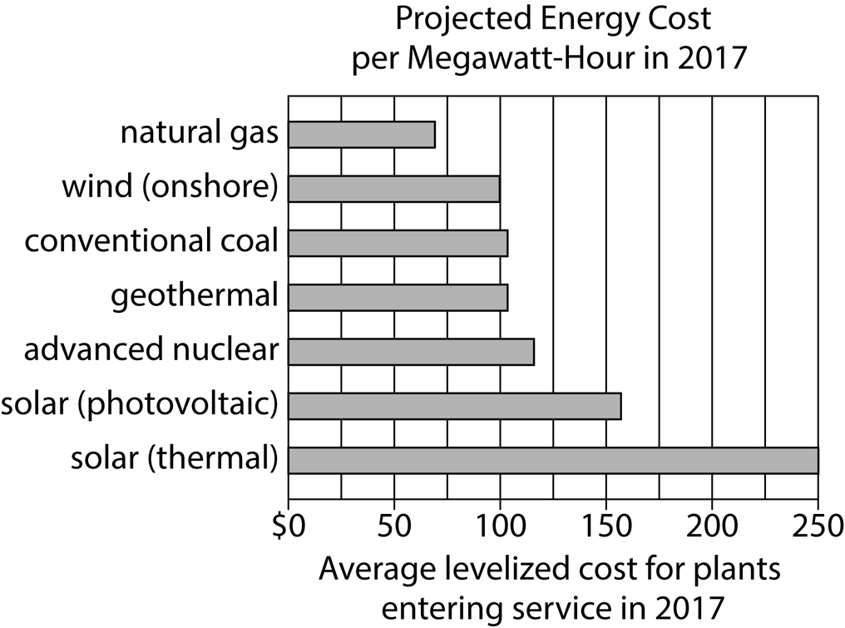
Adapted from Peter Schwartz, “Abundant Natural Gas and Oil Are Putting the Kibosh on Clean Energy.” ©2012 by Condé Nast.

Begin skippable figure description.
Figure 1 presents a horizontal bar graph titled “Projected Energy Cost per Megawatt-Hour in 2017.” There are 7 bars representing 7 types of energy. The horizontal axis is labeled, “Average levelized cost for plants entering service in 2017,” and ranges from 0 dollars to 250 dollars in increments of 50 dollars. From top to bottom, the data represented by each of the 7 bars are as follows. Note that all values are approximate.

Natural gas, 70 dollars.
Wind, onshore, 100 dollars.
Conventional coal, 105 dollars.
Geothermal, 105 dollars.
Advanced nuclear, 115 dollars.
Solar, photovoltaic, 155 dollars.
Solar, thermal, 250 dollars.

End skippable figure description.

Figure 2
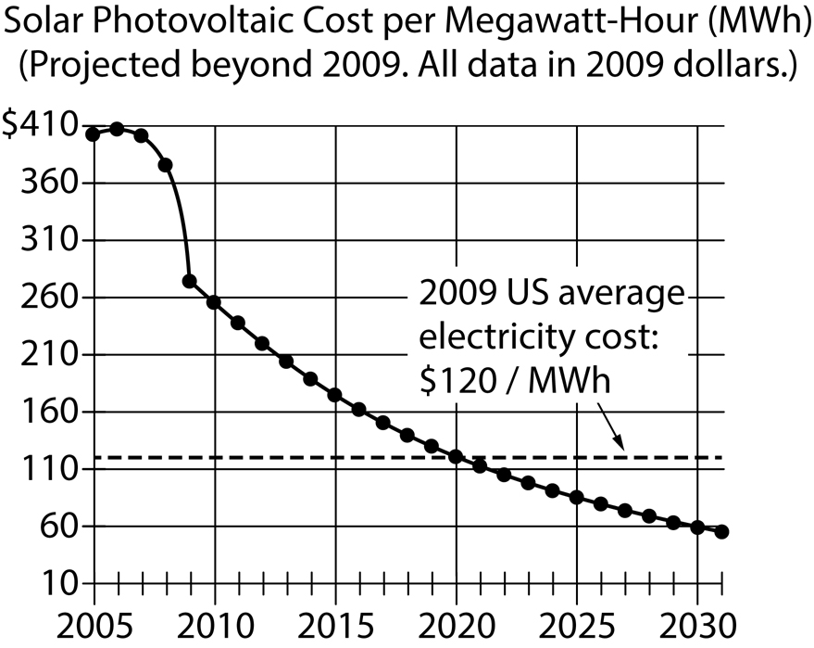
Adapted from Ramez Naam, “Smaller, Cheaper, Faster: Does Moore’s Law Apply to Solar Cells?” ©2011 by Scientific American.

Begin skippable figure description.
Figure 2, which presents a graph with 2 lines, is titled “Solar Photovoltaic Cost per Megawatt-Hour. Projected beyond 2009. All data in 2009 dollars,” meaning the value of a dollar in the year 2009.

The years 2005 through 2030, in increments of 5, appear along the horizontal axis, and the axis itself extends to 2031. The values $10 through $410, in increments of $50, appear along the vertical axis. The behavior of the 2 lines is as follows. Note that all values are approximate.

The first line is a solid line that begins near the top left corner of the graph at $405; it is marked by 27 points along its length, each corresponding to one of the 27 years between 2005 and 2031.

The second line is a dashed line labeled “2009 U S average electricity cost: $120 per megawatt-hour.” The line begins on the vertical axis at approximately $120, moves horizontally to the right, and intersects the solid line in 2020.

End skippable figure description.

Question 43.
The passage is written from the point of view of a
A. consumer evaluating a variety of options.
B. scientist comparing competing research methods.
C. journalist enumerating changes in a field.
D. hobbyist explaining the capabilities of new technology.

Question 44.
As used in sentence 2 of paragraph 1, the word “poor” most nearly means
A. weak.
B. humble.
C. pitiable.
D. obsolete.

Question 45.
It can most reasonably be inferred from the passage that many people in the solar panel industry believe that
A. consumers don’t understand how solar panels work.
B. two-sided cells have weaknesses that have not yet been discovered.
C. the cost of solar panels is too high and their power output too low.
D. Willow Glass is too inefficient to be marketable.

Question 46.
Which choice provides the best evidence for the answer to question 45?
A. Sentence 1 of paragraph 1 (“Solar . . . demand”)
B. Sentence 2 of paragraph 2 (“A few . . . a watt”)
C. Sentence 3 of paragraph 3 (“If so . . . plants”)
D. Sentence 1 of paragraph 4 (“All . . . reductions”)

Question 47.
According to the passage, two-sided solar panels will likely raise efficiency by
A. requiring little energy to operate.
B. absorbing reflected light.
C. being reasonably inexpensive to manufacture.
D. preventing light from reaching the ground.

Question 48.
Which choice provides the best evidence for the answer to question 47?
A. Sentence 2 of paragraph 6 (“The basic . . . plant”)
B. Sentence 3 of paragraph 6 (“That . . . output”)
C. Sentence 4 of paragraph 6 (“This . . . reflective”)
D. Sentence 5 of paragraph 6 (“Where . . . 400 watts”)

Question 49.
As used in sentence 1 of paragraph 7, the phrase “betting on” most nearly means
A. dabbling in.
B. gambling with.
C. switching from.
D. optimistic about.

Question 50.
The last sentence of the passage (sentence 5 of paragraph 7) mainly serves to
A. express concern about the limitations of a material.
B. identify a hurdle that must be overcome.
C. make a prediction about the effective use of certain devices.
D. introduce a potential new area of study.

Question 51.
According to figure 1, in 2017, the cost of which of the following fuels is projected to be closest to the 2009 U S average electricity cost shown in figure 2?
A. Natural gas
B. Wind (onshore)
C. Conventional coal
D. Advanced nuclear

Question 52.
According to figure 2, in what year is the average cost of solar photovoltaic power projected to be equal to the 2009 U S average electricity cost?
A. 2018
B. 2020
C. 2025
D. 2027

Stop.
If you finish before time is called, you may check your work on this section only. Do not go on to any other section.

