The S A T®
Assistive Technology Compatible Test Form

Practice Test 1

Answers and explanations for section 4, Math Test—Calculator

Explanation for question 1.
Correct answer
Choice B is correct. On the graph, a line segment with a positive slope represents an interval over which the target heart rate is strictly increasing as time passes. A horizontal line segment represents an interval over which there is no change in the target heart rate as time passes, and a line segment with a negative slope represents an interval over which the target heart rate is strictly decreasing as time passes. Over the interval between 40 and 60 minutes, the graph consists of a line segment with a positive slope followed by a line segment with a negative slope, with no horizontal line segment in between, indicating that the target heart rate is strictly increasing then strictly decreasing.
Incorrect answer
Choice A is incorrect because the graph over the interval between 0 and 30 minutes contains a horizontal line segment, indicating a period in which there was no change in the target heart rate. Choice C is incorrect because the graph over the interval between 50 and 65 minutes consists of a line segment with a negative slope followed by a line segment with a positive slope, indicating that the target heart rate is strictly decreasing then strictly increasing. Choice D is incorrect because the graph over the interval between 70 and 90 minutes contains horizontal line segments and no segment with a negative slope.

Explanation for question 2.
Correct answer
Choice C is correct. Substituting 6 for x and 24 for y in 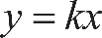 y equals k x gives 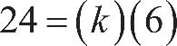 24 equals k times 6, which gives k equals 4. Hence, 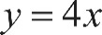 y equals 4 x. Therefore, when x equals 5, the value of y is 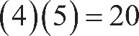 4 times 5, equals 20. None of the other choices for y is correct because y is a function of x, and so there is only one y-value for a given x-value.
Incorrect answer
Choices A, B, and D are incorrect. Choice A is the result of substituting 6 for y and substituting 5 for x in the equation y equals k x, when solving for k. Choice B results from substituting 3 for k and 5 for x in the equation y equals k x, when solving for y. Choice D results from using 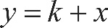 y equals, k plus x instead of y equals k x.

Explanation for question 3.
Correct answer
Choice D is correct. Consider the measures of angle 3 and angle 4 in the following figure.
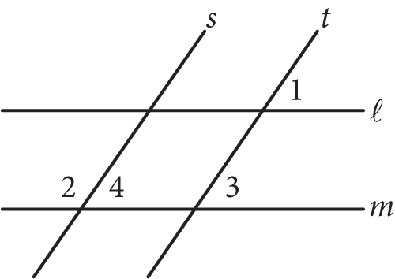

Begin skippable figure description.
This figure is the same figure as is in the question except that two labels, “3” and “4,” are added to two of the angles. The figure presents two horizontal lines l and m, with line l above line m, and two parallel lines s and t that slant upward and to the right, with line s to the left of line t. The slanted lines s and t intersect the horizontal lines l and m. The angle above line l and to the right of line t is labeled “1,” and the angle above horizontal line m and to the right of line t is labeled “3.” The angle above line m and to the left of line s is labeled “2,” and the adjacent angle that is above line m and to the right of line s is labeled “4.”

End skippable figure description.

The measure of angle 3 is equal to the measure of angle 1 because they are corresponding angles for the parallel lines l and m intersected by the transversal line t. Similarly, the measure of angle 3 is equal to the measure of angle 4 because they are corresponding angles for the parallel lines s and t intersected by the transversal line m. Since the measure of angle 1 is 35 degrees, the measures of angle 3 and angle 4 are also 35 degrees. Since angle 4 and angle 2 are supplementary angles, the sum of the measures of these two angles is 180 degrees. Therefore, the measure of angle 2 is 180 degrees, minus 35 degrees, equals 145 degrees.
Incorrect answer
Choice A is incorrect because 35 degrees is the measure of angle 1, and angle 1 is not congruent to angle 2. Choice B is incorrect because it is the measure of the complementary angle of angle 1, and angle 1 and angle 2 are not complementary angles. Choice C is incorrect because it is double the measure of angle 1, which cannot be inferred from the information given.

Explanation for question 4.
Correct answer
Choice C is correct. The description “ 16 plus 4 x is 10 more than 14” can be written as the equation 16 plus 4 x, equals, 10 plus 14, which is equivalent to 16 plus 4 x, equals 24. Subtracting 16 from each side of 16 plus 4 x, equals 24 gives 4 x equals 8. Since 8 x is 2 times 4 x, multiplying both sides of 4 x equals 8 by 2 gives 8 x equals 16. Therefore, the value of 8 x is 16.
Incorrect answer
Choice A is incorrect because it is the value of x, not 8 x. Choices B and D are incorrect and may be the result of errors made when solving the equation 16 plus 4 x, equals, 10 plus 14 for x. For example, choice D could be the result of subtracting 16 from the left side of the equation and adding 16 to the right side of the equation 16 plus 4 x, equals, 10 plus 14, giving 4 x equals 40 and 8 x equals 80.

Explanation for question 5.
Correct answer
Choice D is correct. A graph with a strong negative association between d and t would have the points on the graph closely aligned with a line that has a negative slope. The more closely the points on a graph are aligned with a line, the stronger the association between d and t, and a negative slope indicates a negative association. Of the four graphs, the points on graph D are most closely aligned with a line with a negative slope. Therefore, the graph in choice D has the strongest negative association between d and t.
Incorrect answer
Choice A is incorrect because the points are more scattered than the points in choice D, indicating a weaker negative association between d and t. Choice B is incorrect because the points are aligned to either a curve or possibly a line with a small positive slope. Choice C is incorrect because the points are aligned to a line with a positive slope, indicating a positive association between d and t.

Explanation for question 6.
Correct answer
Choice D is correct. Since there are 10 grams in 1 decagram, there are 2 times 10, equals 20 grams in 2 decagrams. Since there are 1,000 milligrams in 1 gram, there are 20 times 1,000, equals 20,000 milligrams in 20 grams. Therefore, 20,000 1-milligram doses of the medicine can be stored in a 2-decagram container.
Incorrect answer
Choice A is incorrect; 0.002 is the number of grams in 2 milligrams. Choice B is incorrect; it could result from multiplying by 1,000 and dividing by 10 instead of multiplying by both 1,000 and 10 when converting from decagrams to milligrams. Choice C is incorrect; 2,000 is the number of milligrams in 2 grams, not the number of milligrams in 2 decagrams.

Explanation for question 7.
Correct answer
Choice C is correct. Let x represent the number of installations that each unit on the y-axis represents. Then 9 x, 5 x, 6 x, 4 x, and 3.5 x are the number of rooftops with solar panel installations in cities A, B, C, D, and E, respectively. Since the total number of rooftops is 27,500, it follows that 9 x, plus 5 x, plus 6 x, plus 4 x, plus 3.5 x, equals 27,500, which simplifies to 27.5 x, equals, 27,500. Thus, 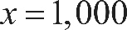 x equals 1,000. Therefore, an appropriate label for the y-axis is “Number of installations (in thousands).”
Incorrect answer
Choices A, B, and D are incorrect and may result from errors when setting up and calculating the units for the y-axis.

Explanation for question 8.
Correct answer
Choice D is correct. If the value of 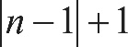 the absolute value of n minus 1, end absolute value, plus 1 is equal to 0, then 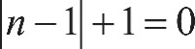 the absolute value of n minus 1, end absolute value, plus 1, equals 0. Subtracting 1 from both sides of this equation gives 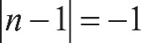 the absolute value of n minus 1, end absolute value, equals, negative 1. The expression 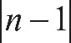 the absolute value of n minus 1, end absolute value on the left side of the equation is the absolute value of n minus 1, and the absolute value of a quantity can never be negative. Thus the absolute value of n minus 1, end absolute value, equals, negative 1 has no solution. Therefore, there are no values for n for which the value of the absolute value of n minus 1, end absolute value, plus 1 is equal to 0.
Incorrect answer
Choice A is incorrect because 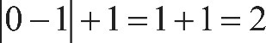 the absolute value of 0 minus 1, end absolute value, plus 1, equals 1 plus 1, which equals 2, not 0. Choice B is incorrect because 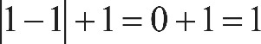 the absolute value of 1 minus 1, end absolute value, plus 1, equals 0 plus 1, which equals 1, not 0. Choice C is incorrect because 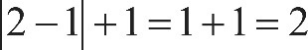 the absolute value of 2 minus 1, end absolute value, plus 1, equals 1 plus 1, which equals 2, not 0.

Explanation for question 9.
Correct answer
Choice A is correct. Subtracting 1,052 from both sides of the equation 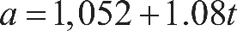 a, equals, 1,052, plus, 1.08, t gives 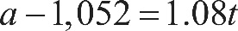 a, minus 1,052, equals 1.08, t. Then dividing both sides of a, minus 1,052, equals, 1.08, t by 1.08 gives 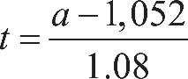 t equals, the fraction with numerator a, minus 1,052, and denominator 1.08.
Incorrect answer
Choices B, C, and D are incorrect and could arise from errors in rewriting a, equals, 1,052, plus, 1.08, t. For example, choice B could result if 1,052 is added to the left side of a, equals, 1,052, plus, 1.08, t and subtracted from the right side, and then both sides are divided by 1.08.

Explanation for question 10.
Correct answer
Choice B is correct. The air temperature at which the speed of a sound wave is closest to 1,000 feet per second can be found by substituting 1,000 for a and then solving for t in the given formula. Substituting 1,000 for a in the equation a, equals, 1,052, plus, 1.08, t gives 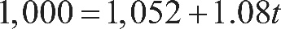 1,000 equals, 1,052, plus, 1.08, t. Subtracting 1,052 from both sides of the equation 1,000 equals, 1,052, plus, 1.08, t and then dividing both sides of the equation by 1.08 yields 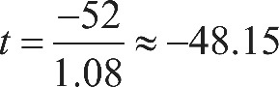 t equals, negative 52 over 1.08, which is approximately equal to, negative 48.15. Of the choices given, negative 48 degrees Fahrenheit is closest to negative 48.15 degrees Fahrenheit.
Incorrect answer
Choices A, C, and D are incorrect and might arise from errors made when substituting 1,000 for a or solving for t in the equation a, equals, 1,052, plus, 1.08, t or in rounding the result to the nearest integer. For example, choice C could be the result of rounding negative 48.15 to negative 49 instead of negative 48.

Explanation for question 11.
Correct answer
Choice A is correct. Subtracting 3 x and adding 3 to both sides of 3 x minus 5, is greater than or equal to, 4 x minus 3 gives negative 2 is greater than or equal to x. Therefore, x is a solution to 3 x minus 5, is greater than or equal to, 4 x minus 3 if and only if x is less than or equal to negative 2 and x is NOT a solution to 3 x minus 5, is greater than or equal to, 4 x minus 3 if and only if x is greater than negative 2. Of the choices given, only negative 1 is greater than negative 2 and, therefore, cannot be a value of x.
Incorrect answer
Choices B, C, and D are incorrect because each is a value of x that is less than or equal to negative 2 and, therefore, could be a solution to the inequality.

Explanation for question 12.
Correct answer
Choice C is correct. The average number of seeds per apple is the total number of seeds in the 12 apples divided by the number of apples, which is 12. On the graph, the horizontal axis is the number of seeds per apple and the height of each bar is the number of apples with the corresponding number of seeds. The first bar on the left indicates that 2 apples have 3 seeds each, the second bar indicates that 4 apples have 5 seeds each, the third bar indicates that 1 apple has 6 seeds, the fourth bar indicates that 2 apples have 7 seeds each, and the fifth bar indicates that 3 apples have 9 seeds each. Thus, the total number of seeds for the 12 apples is open parenthesis, 2 times 3, close parenthesis, plus, open parenthesis, 4 times 5, close parenthesis, plus, open parenthesis, 1 times 6, close parenthesis, plus, open parenthesis, 2 times 7, close parenthesis, plus, open parenthesis, 3 times 9, close parenthesis, equals 73, and the average number of seeds per apple is 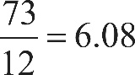 73 over 12 equals 6.08. Of the choices given, 6 is closest to 6.08.
Incorrect answer
Choice A is incorrect; it is the number of apples represented by the tallest bar but is not the average number of seeds for the 12 apples. Choice B is incorrect; it is the number of seeds per apple corresponding to the tallest bar, but is not the average number of seeds for the 12 apples. Choice D is incorrect; a student might choose this value by correctly calculating the average number of seeds, 6.08, but incorrectly rounding up to 7.

Explanation for question 13.
Correct answer
Choice C is correct. From the table, there was a total of 310 survey respondents, and 19% of all survey respondents is equivalent to 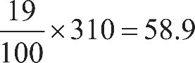 the fraction 19 over 100, end fraction, times 310, equals 58.9 respondents. Of the choices given, 59, the number of males taking Geometry, is closest to 58.9 respondents.
Incorrect answer
Choices A, B, and D are incorrect because the number of males taking Geometry is closer to 58.9 (which is 19% of 310) than the number of respondents in each of these categories.

Explanation for question 14.
Correct answer
Choice C is correct. The range of the lengths of the 21 fish represented in the table is 24 minus 8, equals 6 inches, and the range of the remaining 20 lengths after the 24-inch measurement is removed is 16 minus 8, equals 8 inches. Therefore, after the 24-inch measurement is removed, the change in range, 8 inches, is much greater than the change in the mean or median.
Incorrect answer
Choice A is incorrect. Let m be the mean of the lengths, in inches, of the 21 fish. Then the sum of the lengths, in inches, of the 21 fish is 21 m. After the 24-inch measurement is removed, the sum of the lengths, in inches, of the remaining 20 fish is 21 m, minus 24, and the mean length, in inches, of these 20 fish is 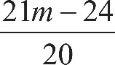 the fraction with numerator 21 m minus 24, and denominator 20, which is a change of 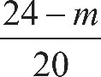 the fraction with numerator 24 minus m, and denominator 20 inches. Since m must be between the smallest and largest measurements of the 21 fish, it follows that 8 is less than m, which is less than 24, from which it can be seen that the change in the mean, in inches, is between 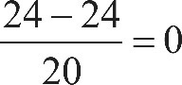 the fraction with numerator 24 minus 24, and denominator 20, equals 0 and 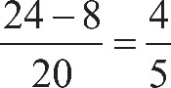 the fraction with numerator 24 minus 8, and denominator 20, equals 4 over 5, and so must be less than the change in the range, 8 inches. Choice B is incorrect because the median length of the 21 fish represented in the table is 12, and after the 24-inch measurement is removed, the median of the remaining 20 lengths is also 12. Therefore, the change in the median (0) is less than the change in the range (8). Choice D is incorrect because the changes in the mean, median, and range of the measurements are different.

Explanation for question 15.
Correct answer
Choice A is correct. The total cost C of renting a boat is the sum of the initial cost to rent the boat plus the product of the cost per hour and the number of hours, h, that the boat is rented. The C-intercept is the point on the C-axis where h, the number of hours the boat is rented, is 0. Therefore, the C-intercept is the initial cost of renting the boat.
Incorrect answer
Choice B is incorrect because the graph represents the cost of renting only one boat. Choice C is incorrect because the total number of hours of rental is represented by h-values, each of which corresponds to the first coordinate of a point on the graph not the C-intercept of the graph. Choice D is incorrect because the increase in cost for each additional hour is given by the slope of the line, not by the C-intercept.

Explanation for question 16.
Correct answer
Choice C is correct. If m is the slope and b is the C-intercept of the line, the relationship between h and C can be represented by C equals, m h plus b. The C-intercept of the line is 5. Since the points 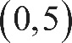 with coordinates 0 comma 5 and 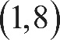 1 comma 8 lie on the line, the slope of the line is 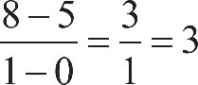 the fraction with numerator 8 minus 5, and denominator 1 minus 0, end fraction, equals 3 over 1, which equals 3. Therefore, the relationship between h and C can be represented by C equals, 3 h plus 5, the slope-intercept equation of the line.
Incorrect answer
Choices A and D are incorrect because each of these equations represents a line that passes through the origin 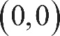 0 comma 0. However, C is not equal to zero when h equals 0. Choice B is incorrect and may result from errors made when reading the scale on each axis as related to calculating the slope.

Explanation for question 17.
Correct answer
Choice B is correct. The minimum value of the function corresponds to the y-coordinate of the point on the graph that has the smallest y-coordinate on the graph. Since the smallest y-coordinate belongs to the point with coordinates 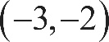 negative 3 comma negative 2, the minimum value of the graph is 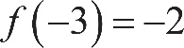 f of negative 3, equals, negative 2. Therefore, the minimum value of 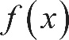 f of x is at x equals negative 3.
Incorrect answer
Choice A is incorrect; negative 5 is the least value for an x-coordinate, not the y-coordinate, of a point on the graph of 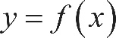 y equals, f of x. Choice C is incorrect; it is the minimum value of f, not the value of x that corresponds to the minimum of f. Choice D is incorrect; it is the value of x for which the value of f of x has its maximum, not minimum.

Explanation for question 18.
Correct answer
Choice A is correct. Since the ordered pair 0 comma 0 is a solution to the system of inequalities, substituting 0 for x and 0 for y in the given system must result in two true inequalities. After this substitution, y is less than, negative x plus a becomes 0 is less than a, and 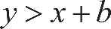 y is greater than x plus b becomes 0 is greater than b. Hence, a is positive and b is negative. Therefore, a, is greater than b.
Incorrect answer
Choice B is incorrect because b is greater than a cannot be true if b is negative and a is positive. Choice C is incorrect because it is possible to find an example where the ordered pair 0 comma 0 is a solution to the system, but 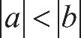 the absolute value of a is less than the absolute value of b; for example, if a, equals 6 and b equals negative 7. Choice D is incorrect because the equation a, equals negative b doesn’t have to be true; for example, the ordered pair 0 comma 0 is a solution to the system of inequalities if a, equals 1 and b equals negative 2.

Explanation for question 19.
Correct answer
Choice B is correct. To determine the number of salads sold, write and solve a system of two equations. Let x equal the number of salads sold and let y equal the number of drinks sold. Since a total of 209 salads and drinks were sold, the equation 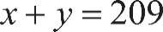 x plus y, equals 209 must hold. Since salads cost $6.50 each, drinks cost $2.00 each, and the total revenue from selling x salads and y drinks was $836.50, the equation 6.50 x, plus 2.00 y, equals, 836.50 must also hold. The equation x plus y, equals 209 is equivalent to 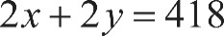 2 x plus 2 y, equals 418, and subtracting 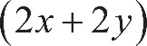 open parenthesis, 2 x plus 2 y, close parenthesis from the left-hand side and subtracting 418 from the right-hand side of 6.50 x, plus 2.00 y, equals, 836.50 gives 4.5 x, equals 418.50. Therefore, the number of salads sold, x, was 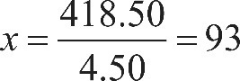 x equals, 418.50, over 4.50, which equals 93.
Incorrect answer
Choices A, C, and D are incorrect and could result from errors in writing the equations and solving the system of equations. For example, choice C could have been obtained by dividing the total revenue, $836.50, by the total price of a salad and a drink, $8.50, and then rounding up.

Explanation for question 20.
Correct answer
Choice D is correct. Let x be the original price of the computer, in dollars. The discounted price is 20 percent off the original price, so x minus 0.2 x, equals 0.8 x is the discounted price, in dollars. The sales tax is 8 percent of the discounted price, so 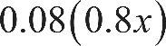 0.08, times, 0.8 x represents the sales tax Alma paid. The price p, in dollars, that Alma paid the cashiers is the sum of the discounted price and the tax: 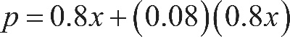 p equals, 0.8 x, plus, 0.08 times 0.8 x which can be rewritten as 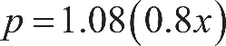 p equals, 1.08 times, 0.8 x. Therefore, the original price, x, of the computer, in dollars, can be written as 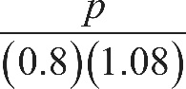 the fraction with numerator p, and denominator 0.8 times 1.08, end fraction in terms of p.
Incorrect answer
Choices A, B, and C are incorrect. The expression in choice A represents 88% of the amount Alma paid to the cashier, and can be obtained by subtracting the discount of 20% from the original price and adding the sales tax of 8%. However, this is incorrect because 8% of the tax is over the discounted price, not the original one. The expression in choice B is the result of adding the factors associated with the discount and sales tax, 0.8 and .08, rather than multiplying them. The expression in choice C results from assigning p to represent the original price of the laptop, rather than to the amount Alma paid to the cashier.

Explanation for question 21.
Correct answer
Choice C is correct. The probability that a person from Group Y who recalled at least 1 dream was chosen at random from the group of all people who recalled at least 1 dream is equal to the number of people in Group Y who recalled at least 1 dream divided by the total number of people in the two groups who recalled at least 1 dream. The number of people in Group Y who recalled at least 1 dream is the sum of the 11 people in Group Y who recalled 1 to 4 dreams and the 68 people in Group Y who recalled 5 or more dreams: 11 plus 68, equals 79. The total number of people who recalled at least 1 dream is the sum of the 79 people in Group Y who recalled at least 1 dream, the 28 people in Group X who recalled 1 to 4 dreams, and the 57 people in Group X who recalled 5 or more dreams: 79 plus 28, plus 57, equals 164. Therefore, the probability is 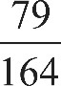 79 over 164.
Incorrect answer
Choice A is incorrect; it is the probability of choosing at random a person from Group Y who recalled 5 or more dreams. Choice B is incorrect; it is the probability of choosing at random a person from Group Y who recalled at least 1 dream. Choice D is incorrect; it is the probability of choosing at random a person from the two groups combined who recalled at least 1 dream.

Explanation for question 22.
Correct answer
Choice B is correct. The amounts given in the table are in thousands of dollars. Therefore, the amount in the annual budget for agriculture/natural resources is actually $488,106,000 in 2010 and $358,708,000 in 2008. Therefore, the change in the budgeted amount is $488,106,000, minus $358,708,000, equals, $129,398,000. Hence, the average change in the annual budget for agriculture/natural resources from 2008 to 2010 is 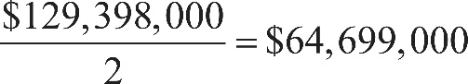 $129,398,000, over 2, equals, $64,699,000 per year. Of the options given, this average rate of change is closest to $65,000,000 per year.
Incorrect answer
Choices A and C are incorrect and may result from errors in setting up or calculating the average rate of change. Choice D is incorrect; $130,000,000 is the approximate total change in the annual budget for agriculture/natural resources from 2008 to 2010, not the average rate of change from 2008 to 2010.

Explanation for question 23.
Correct answer
Choice B is correct. The human resources budget in 2007 was 4,051,050 thousand dollars, and the human resources budget in 2010 was 5,921,379 thousand dollars. Therefore, the ratio of the 2007 budget to the 2010 budget is slightly greater than 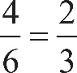 4 over 6, equals 2 over 3. Similar estimates for agriculture/natural resources give a ratio of the 2007 budget to the 2010 budget of slightly greater than 3 over 4; for education, a ratio of slightly greater than 2 over 3; for highways and transportation, a ratio of slightly less than 5 over 6; and for public safety, a ratio of slightly greater than 5 over 9. Therefore, of the given choices, education’s ratio of the 2007 budget to the 2010 budget is closest to that of human resources.
Incorrect answer
Choices A, C, and D are incorrect because the ratio of the 2007 budget to 2010 budget for each of the programs given in these choices is further from the corresponding ratio for human resources than the corresponding ratio for education.

Explanation for question 24.
Correct answer
Choice A is correct. The equation of a circle can be written as 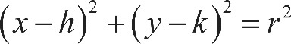 open parenthesis, x minus h, close parenthesis, squared, plus, open parenthesis, y minus k, close parenthesis, squared, equals r squared where 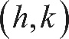 h comma k are the coordinates of the center of the circle and r is the radius of the circle. Since the coordinates of the center of the circle are 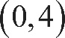 0 comma 4, the equation of the circle is 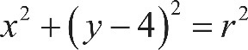 x squared, plus, open parenthesis, y minus 4, close parenthesis, squared, equals r squared. The radius of the circle is the distance from the center, the point with coordinates 0 comma 4, to the given endpoint of a radius, 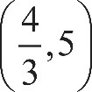 the point with coordinates four thirds, comma 5. By the distance formula, 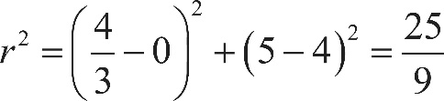 r squared, equals, open parenthesis, four thirds minus 0, close parenthesis, squared, plus, open parenthesis, 5 minus 4, close parenthesis, squared, equals, the fraction 25 over 9. Therefore, an equation of the given circle is 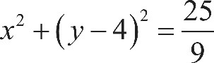 x squared, plus, open parenthesis, y minus 4, close parenthesis, squared, equals, the fraction 25 over 9.
Incorrect answer
Choices B and D are incorrect. The equations given in these choices represent a circle with center 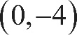 0 comma negative 4, not 0 comma 4. Choice C is incorrect; it results from using r instead of r squared in the equation for the circle.

Explanation for question 25.
Correct answer
Choice D is correct. When the ball hits the ground, its height is 0 meters. Substituting 0 for h in 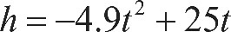 h equals, negative 4.9, t squared, plus 25 t gives 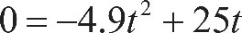 0 equals, negative 4.9, t squared, plus 25 t, which can be rewritten as 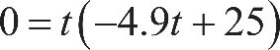 0 equals, t times, open parenthesis, negative 4.9, t, plus 25, close parenthesis. Thus, the possible values of t are t equals 0 and 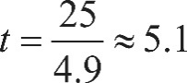 t equals, 25 over 49, which is approximately equal to 5.1. The time t equals 0 seconds corresponds to the time the ball is launched from the ground, and the time t approximately equal to 5.1 seconds corresponds to the time after launch that the ball hits the ground. Of the given choices, 5.0 seconds is closest to 5.1 seconds, so the ball returns to the ground approximately 5.0 seconds after it is launched.
Incorrect answer
Choice A, B, and C are incorrect and could arise from conceptual or computation errors while solving 0 equals, negative 4.9, t squared, plus 25 t for t.

Explanation for question 26.
Correct answer
Choice B is correct. Let x represent the number of pears produced by the Type B trees. Type A trees produce 20 percent more pears than Type B trees, or x, which can be represented as x plus 0.20 x, equals 1.20 x pears. Since Type A trees produce 144 pears, it follows that 1.20 x, equals 144. Thus 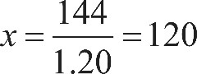 x equals, 144 over 1.20, which equals 120. Therefore, the Type B trees produced 120 pears.
Incorrect answer
Choice A is incorrect because while 144 is reduced by approximately 20 percent, increasing 115 by 20 percent gives 138, not 144. Choice C is incorrect; it results from subtracting 20 from the number of pears produced by the Type A trees. Choice D is incorrect; it results from adding 20 percent of the number of pears produced by Type A trees to the number of pears produced by Type A trees.

Explanation for question 27.
Correct answer
Choice C is correct. The area of the field is 100 square meters. Each 1-meter-by-1-meter square has an area of 1 square meter. Thus, on average, the earthworm counts to a depth of 5 centimeters for each of the regions investigated by the students should be about 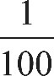 one hundredth of the total number of earthworms to a depth of 5 centimeters in the entire field. Since the counts for the smaller regions are from 107 to 176, the estimate for the entire field should be between 10,700 and 17,600. Therefore, of the given choices, 15,000 is a reasonable estimate for the number of earthworms to a depth of 5 centimeters in the entire field.
Incorrect answer
Choice A is incorrect; 150 is the approximate number of earthworms in 1 square meter. Choice B is incorrect; it results from using 10 square meters as the area of the field. Choice D is incorrect; it results from using 1,000 square meters as the area of the field.

Explanation for question 28.
Correct answer
Choice C is correct. To determine which quadrant does not contain any solutions to the system of inequalities, graph the inequalities. Graph the inequality 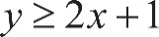 y is greater than or equal to, 2 x plus 1 by drawing a line through the y-intercept 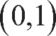 with coordinates 0 comma 1 and the point 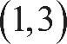 with coordinates 1 comma 3, as shown. The solutions to this inequality are all points contained on and above this line. Graph the inequality 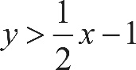 y is greater than, one half x, minus 1 by drawing a dashed line through the y-intercept 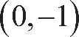 with coordinates 0 comma negative 1 and the point 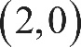 with coordinates 2 comma 0, as shown. The solutions to this inequality are all points above this dashed line.
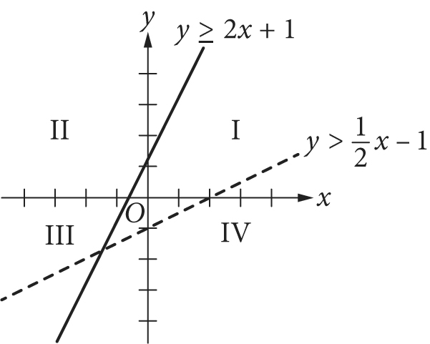

Begin skippable figure description.
The figure presents the graph of two lines in the x y-plane, with four quadrants labeled quadrant 1, quadrant 2, quadrant 3, and quadrant 4. Of the two lines, one is a solid line, labeled “y is greater than or equal to, 2 x plus 1.” The solid line begins in quadrant 3, slants upward and to the right, passing through quadrant 2, and extends in quadrant 1. It crosses the y axis at 1 and passes through the point with coordinates 1 comma 3. The other line is a dashed line, labeled “y is greater than, one half x, minus 1.” The dashed line begins in quadrant 3 above the solid line. It slants upward and to the right and stays above the solid line, until it intersects the solid line in quadrant 3. It then remains below the solid line, crosses the y axis at negative 1, passes through quadrant 4, crosses the x axis at 2, and extends in quadrant 1.

End skippable figure description.

The solution to the system of inequalities is the intersection of the regions above the graphs of both lines. It can be seen that the solutions only include points in quadrants 1, 2, and 3 and do not include any points in quadrant 4.
Incorrect answer
Choices A and B are incorrect because quadrants 2 and 3 contain solutions to the system of inequalities, as shown in the figure above. Choice D is incorrect because there are no solutions in quadrant 4.

Explanation for question 29.
Correct answer
Choice D is correct. If the polynomial 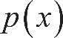 p of x is divided by x minus 3, the result can be written as 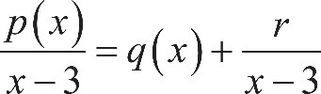 the fraction with numerator p of x, and denominator x minus 3, end fraction, equals, q of x plus, the fraction r over, x minus 3, end fraction, where 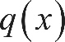 q of x is a polynomial and r is the remainder. Since x minus 3 is a degree 1 polynomial, the remainder is a real number. Hence, p of x can be written as 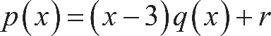 p of x equals, open parenthesis, x minus 3, close parenthesis, times, q of x, plus r, where r is a real number. It is given that 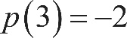 p of 3, equals, negative 2 so it must be true that negative 2 equals, p of 3, which equals, open parenthesis, 3 minus 3, close parenthesis, times, q of 3, plus r, which equals, 0 times, q of 3, plus r, equals r. Therefore, the remainder when p of x is divided by x minus 3 is negative 2.
Incorrect answer
Choice A is incorrect because p of 3 equals, negative 2 does not imply that 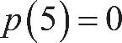 p of 5, equals 0. Choices B and C are incorrect because the remainder negative 2 or its opposite, 2, need not be a root of p of x.

Explanation for question 30.
Correct answer
Choice D is correct. Any quadratic function q can be written in the form 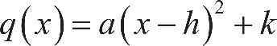 q of x, equals, a, times, open parenthesis, x minus h, close parenthesis, squared, plus k, where a, h, and k are constants and the point with coordinates h comma k is the vertex of the parabola when q is graphed in the coordinate plane. This form can be reached by completing the square in the expression that defines q. The equation of the graph is 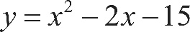 y equals, x squared, minus 2 x, minus 15.

Since the coefficient of x is negative 2, this equation can be written in terms of 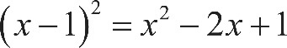 open parenthesis, x minus 1, close parenthesis, squared, equals, x squared, minus 2 x, plus 1 as follows: y equals, x squared, minus 2 x, minus 15, equals, open parenthesis, x squared, minus 2 x, plus 1, close parenthesis, minus 16, which equals, open parenthesis, x minus 1, close parenthesis, squared, minus 16. From this form of the equation, the coefficients of the vertex can be read as 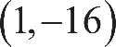 1 comma negative 16.
Incorrect answer
Choices A and C are incorrect because the coordinates of the vertex A do not appear as constants in these equations. Choice B is incorrect because it is not equivalent to the given equation.

Explanation for question 31.
Correct answer
The correct answer is any number between 4 and 6, inclusive. Since Wyatt can husk at least 12 dozen ears of corn per hour, it will take him no more than 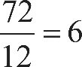 72 over 12, equals 6 hours to husk 72 dozen ears of corn. On the other hand, since Wyatt can husk at most 18 dozen ears of corn per hour, it will take him at least 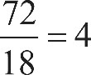 72 over 18, equals 4 hours to husk 72 dozen ears of corn. Therefore, the possible times it could take Wyatt to husk 72 dozen ears of corn are 4 hours to 6 hours, inclusive. Any number between 4 and 6, inclusive, can be gridded as the correct answer.

Explanation for question 32.
Correct answer
The correct answer is 107. Since the weight of the empty truck and its driver is 4500 pounds and each box weighs 14 pounds, the weight, in pounds, of the delivery truck, its driver, and x boxes is 4,500 plus 14 x. This weight is below the bridge’s posted weight limit of 6000 pounds if 4,500 plus 14 x, is less than 6,000. Subtracting 4500 from both sides of this inequality and then dividing both sides by 14 yields 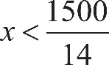 x is less than 1,500 over 14 or 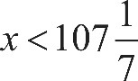 x is less than the mixed number 107 and one seventh. Since the number of packages must be an integer, the maximum possible value for x that will keep the combined weight of the truck, its driver, and the x identical boxes below the bridge’s posted weight limit is 107.

Explanation for question 33.
Correct answer
The correct answer is 5 over 8 or .625. Based on the line graph, the number of portable media players sold in 2008 was 100 million, and the number of portable media players sold in 2011 was 160 million. Therefore, the number of portable media players sold in 2008 is 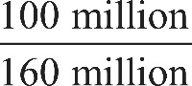 100 million over 160 million of the portable media players sold in 2011. This fraction reduces to 5 over 8. Either 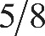 5 slash 8 or its decimal equivalent, .625, may be gridded as the correct answer.

Explanation for question 34.
Correct answer
The correct answer is 96. Since each day has a total of 24 hours of time slots available for the station to sell, there is a total of 48 hours of time slots available to sell on Tuesday and Wednesday. Each time slot is a 30-minute interval, which is equal to a one half-hour interval. Therefore, there are a 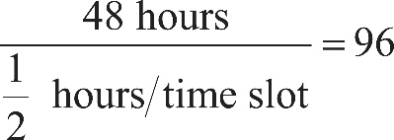 the fraction with numerator 48 hours, and denominator one half hours over time slot, end fraction, equals 96 time slots of 30 minutes for the station to sell on Tuesday and Wednesday.

Explanation for question 35.
Correct answer
The correct answer is 6. The volume of a cylinder is 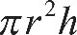 pi, r squared, times h, where r is the radius of the base of the cylinder and h is the height of the cylinder. Since the storage silo is a cylinder with volume 72 pi cubic yards and height 8 yards, it follows that 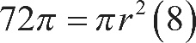 72 pi, equals, pi, r squared, times 8, where r is the radius of the base of the cylinder, in yards. Dividing both sides of the equation 72 pi, equals, pi, r squared, times 8 by 8 pi gives 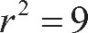 r squared, equals 9, and so the radius of the base of the cylinder is 3 yards. Therefore, the diameter of the base of the cylinder is 6 yards.

Explanation for question 36.
Correct answer
The correct answer is 3. The function 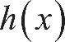 h of x is undefined when the denominator of 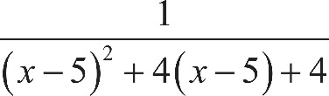 the fraction with numerator 1, and denominator, open parenthesis, x minus 5, close parenthesis, squared, plus 4 times, open parenthesis, x minus 5, close parenthesis, plus 4, end fraction is equal to zero. The expression 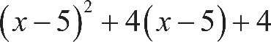 open parenthesis, x minus 5, close parenthesis, squared, plus 4 times, open parenthesis, x minus 5, close parenthesis, plus 4 is a perfect square: 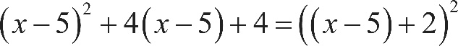 open parenthesis, x minus 5, close parenthesis, squared, plus 4 times, open parenthesis, x minus 5, close parenthesis, plus 4, equals, open parenthesis, open parenthesis, x minus 5, close parenthesis, plus 2, close parenthesis, squared, which can be rewritten as 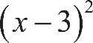 open parenthesis, x minus 3, close parenthesis, squared. The expression open parenthesis, x minus 3, close parenthesis, squared is equal to zero if and only if x equals 3. Therefore, the value of x for which h of x is undefined is 3.

Explanation for question 37.
Correct answer
The correct answer is 1.02. The initial deposit earns 2 percent interest compounded annually. Thus at the end of 1 year, the new value of the account is the initial deposit of $100 plus 2 percent of the initial deposit: 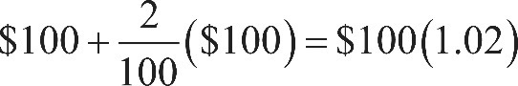 $100, plus the fraction 2 over 100, end fraction, times $100, equals, $100, times 1.02. Since the interest is compounded annually, the value at the end of each succeeding year is the sum of the previous year’s value plus 2 percent of the previous year’s value. This is again equivalent to multiplying the previous year’s value by 1.02. Thus, after 2 years, the value will be 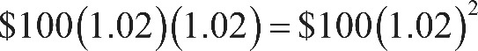 $100, times 1.02, times 1.02, equals, $100, times, open parenthesis, 1.02, close parenthesis, squared; after 3 years, the value will be 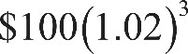 $100, times, open parenthesis, 1.02, close parenthesis, cubed; and after t years, the value will be 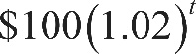 $100 times, open parenthesis, 1.02, close parenthesis, raised to the t power. Therefore, in the formula for the value for Jessica’s account after t years, 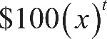 $100, times, open parenthesis, x, close parenthesis, raised to the t power, the value of x must be 1.02.

Explanation for question 38.
Correct answer
The correct answer is 6.11. Jessica made an initial deposit of $100 into her account. The interest on her account is 2 percent compounded annually, so after 10 years, the value of her initial deposit has been multiplied 10 times by the factor 1 plus 0.02, equals, 1.02. Hence, after 10 years, Jessica’s deposit is worth 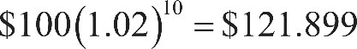 $100, times, open parenthesis, 1.02, close parenthesis, raised to the tenth power, which equals, $121.899 to the nearest tenth of a cent. Tyshaun made an initial deposit of $100 into his account. The interest on his account is 2.5 percent compounded annually, so after 10 years, the value of his initial deposit has been multiplied 10 times by the factor 1 plus, 0.025, equals, 1.025. Hence, after 10 years, Tyshaun’s deposit is worth 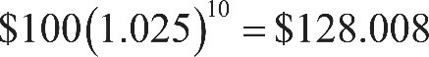 $100, times, open parenthesis, 1.025, close parenthesis, raised to the tenth power, which equals, $128.008 to the nearest tenth of a cent. Hence, Jessica’s initial deposit earned $21.899 and Tyshaun’s initial deposit earned $28.008. Therefore, to the nearest cent, Tyshaun’s initial deposit earned $6.11 more than Jessica’s initial deposit.

