The S A T®
Assistive Technology Compatible Test Form

Practice Test 9

Answers and explanations for section 4, Math Test—Calculator

Explanation for question 1.
Correct answer
Choice B is correct. Subtracting 3 from both sides of the equation yields 3 x equals 24. Dividing both sides of this equation by 3 yields x equals 8.
Incorrect answer
Choice A is incorrect and may result from finding a common factor among the three given terms instead of finding x. Choice C is incorrect and may result from incorrectly adding 3 to, instead of subtracting 3 from, the right-hand side of the equation. Choice D is incorrect. This is the value of 3 x plus 3, not the value of x.

Explanation for question 2.
Correct answer
Choice D is correct. Since 1 cubit is equivalent to 7 palms, 140 cubits are equivalent to 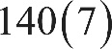 140 times 7 palms, or 980 palms.
Incorrect answer
Choice A is incorrect and may result from dividing 7 by 140. Choice B is incorrect and may result from dividing 140 by 7. Choice C is incorrect. This is the length of the Great Sphinx statue in cubits, not palms.

Explanation for question 3.
Correct answer
Choice B is correct. Multiplying both sides of the given equation by 5 yields 2 n equals 50. Substituting 50 for 2 n in the expression 2 n minus 1 yields 50 minus 1, equals 49.

Alternate approach: Dividing both sides of 2 n equals 50 by 2 yields n equals 25. Evaluating the expression 2 n minus 1 for n equals 25 yields 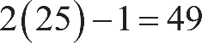 2 times 25, minus 1, equals 49.
Incorrect answer
Choice A is incorrect and may result from finding the value of n minus 1 instead of 2 n minus 1. Choice C is incorrect and may result from finding the value of 2 n instead of 2 n minus 1. Choice D is incorrect and may result from finding the value of 4 n minus 1 instead of 2 n minus 1.

Explanation for question 4.
Correct answer
Choice A is correct. The square root symbol represents the principal, or nonnegative, square root. Therefore, the equation 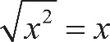 the square root of x squared, end root, equals x is only true for values of x greater than or equal to 0. Thus, negative 4 isn’t a solution to the given equation.
Incorrect answer
Choices B, C, and D are incorrect because these values of x are solutions to the equation the square root of x squared, end root, equals x. Choosing one of these as a value of x that isn’t a solution may result from incorrectly using the rules of exponents or incorrectly evaluating these values in the given equation.

Explanation for question 5.
Correct answer
Choice D is correct. The x-axis of the graph represents the time, in minutes, after the coffee was removed from the heat source, and the y-axis of the graph represents the temperature, in degrees Fahrenheit, of the coffee. The coffee was first removed from the heat source when x equals 0. The graph shows that when x equals 0, the y-value was a little less than 200 degrees Fahrenheit. Of the answer choices given, 195 is the best approximation.
Incorrect answer
Choice A is incorrect and may result from finding the temperature after 140 minutes. Choice B is incorrect and may result from finding the temperature after 50 minutes. Choice C is incorrect and may result from finding the temperature after 10 minutes.

Explanation for question 6.
Correct answer
Choice A is correct. The average rate of change in temperature of the coffee in degrees Fahrenheit per minute is calculated by dividing the difference between two recorded temperatures by the number of minutes in the corresponding interval of time. Since the time intervals given are all 10 minutes, the average rate of change is greatest for the points with the greatest difference in temperature. Of the choices, the greatest difference in temperature occurs between 0 and 10 minutes.
Incorrect answer
Choices B, C, and D are incorrect and may result from misinterpreting the average rate of change from the graph.

Explanation for question 7.
Correct answer
Choice C is correct. It’s given that x equals 100; therefore, substituting 100 for x in triangle A B C gives two known angle measures for this triangle. The sum of the measures of the interior angles of any triangle equals 180 degrees. Subtracting the two known angle measures of triangle A B C from 180 degrees gives the third angle measure: 180 degrees minus 100 degrees, minus 20 degrees, equals 60 degrees. This is the measure of angle B C A. Since vertical angles are congruent, the measure of angle D C E is also 60 degrees. Subtracting the two known angle measures of triangle C D E from 180 degrees gives the third angle measure: 180 degrees minus 60 degrees, minus 40 degrees, equals 80 degrees. Therefore, the value of y is 80.
Incorrect answer
Choice A is incorrect and may result from a calculation error. Choice B is incorrect and may result from classifying angle C D E as a right angle. Choice D is incorrect and may result from finding the measure of angle B C A or D C E instead of the measure of angle C D E.

Explanation for question 8.
Correct answer
Choice A is correct. The cost of each additional mile traveled is represented by the slope of the given line. The slope of the line can be calculated by identifying two points on the line and then calculating the ratio of the change in y to the change in x between the two points. Using the points 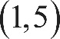 with coordinates 1 comma 5 and 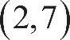 2 comma 7, the slope is equal to 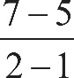 the fraction with numerator 7 minus 5, and denominator 2 minus 1, end fraction or 2. Therefore, the cost for each additional mile traveled of the cab ride is $2.00.
Incorrect answer
Choice B is incorrect and may result from calculating the slope of the line that passes through the points 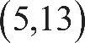 with coordinates 5 comma 13 and 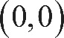 0 comma 0. However, the point with coordinates 0 comma 0 does not lie on the line shown. Choice C is incorrect. This is the y-coordinate of the y-intercept of the graph and represents the flat fee for a cab ride before the charge for any miles traveled is added. Choice D is incorrect. This value represents the total cost of a 1-mile cab ride.

Explanation for question 9.
Correct answer
Choice D is correct. The total number of gas station customers on Tuesday was 135. The table shows that the number of customers who did not purchase gasoline was 50. Finding the ratio of the number of customers who did not purchase gasoline to the total number of customers gives the probability that a customer selected at random on that day did not purchase gasoline, which is 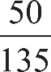 50 over 135.
Incorrect answer
Choice A is incorrect and may result from finding the probability that a customer did not purchase a beverage, given that the customer did not purchase gasoline. Choice B is incorrect and may result from finding the probability that a customer did not purchase gasoline, given that the customer did not purchase a beverage. Choice C is incorrect and may result from finding the probability that a customer did purchase a beverage, given that the customer did not purchase gasoline.

Explanation for question 10.
Correct answer
Choice D is correct. It is given that the number of students surveyed was 336. Finding one fourth of 336 yields 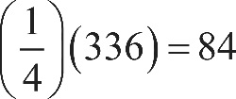 one fourth times 336, equals 84, the number of freshmen, and finding one third of 336 yields 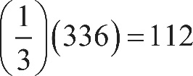 one third times 336, equals 112, the number of sophomores. Subtracting these numbers from the total number of selected students results in 336 minus 84, minus 112, equals 140, the number of juniors and seniors combined. Finding half of this total yields 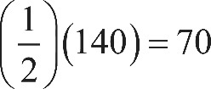 one half times 140, equals 70, the number of juniors. Subtracting this number from the number of juniors and seniors combined yields 140 minus 70, equals 70, the number of seniors.
Incorrect answer
Choices A and C are incorrect and may result from calculation errors. Choice B is incorrect. This is the total number of juniors and seniors.

Explanation for question 11.
Correct answer
Choice A is correct. It’s given that the ratio of the heights of Plant A to Plant B is 20 to 12 and that the height of Plant C is 54 centimeters. Let x be the height of Plant D. The proportion 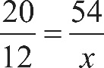 20 over 12, equals, 54 over x can be used to solve for the value of x. Multiplying both sides of this equation by x yields 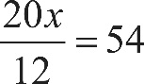 20 x over 12, equals 54 and then multiplying both sides of this equation by 12 yields 20 x equals 648. Dividing both sides of this equation by 20 yields x equals 32.4 centimeters.
Incorrect answer
Choice B is incorrect and may result from a calculation error. Choice C is incorrect and may result from finding the difference in heights between Plant A and Plant B and then adding that to the height of Plant C. Choice D is incorrect and may result from using the ratio 12 to 20 rather than 20 to 12.

Explanation for question 12.
Correct answer
Choice D is correct. It’s given that 1 kilometer is approximately equivalent to 0.6214 miles. Let x be the number of kilometers equivalent to 3.1 miles. The proportion 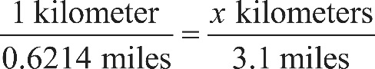 1 kilometer over 0.6214 miles, equals, x kilometers over 3.1 miles can be used to solve for the value of x. Multiplying both sides of this equation by 3.1 yields 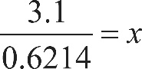 3.1 over 0.6214, equals x, or x is approximately equal to 4.99. This is approximately 5 kilometers.
Incorrect answer
Choice A is incorrect and may result from misidentifying the ratio of kilometers to miles as miles to kilometers. Choice B is incorrect and may result from calculation errors. Choice C is incorrect and may result from calculation and rounding errors.

Explanation for question 13.
Correct answer
Choice C is correct. Let a equal the number of 120-pound packages, and let b equal the number of 100-pound packages. It’s given that the total weight of the packages can be at most 1,100 pounds: the inequality 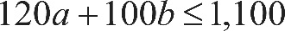 120 a, plus 100 b, is less than or equal to 1,100 represents this situation. It’s also given that the helicopter must carry at least 10 packages: the inequality a, plus b, is greater than or equal to 10 represents this situation. Values of a and b that satisfy these two inequalities represent the allowable numbers of 120-pound packages and 100-pound packages the helicopter can transport. To maximize the number of 120-pound packages, a, in the helicopter, the number of 100-pound packages, b, in the helicopter needs to be minimized. Expressing b in terms of a in the second inequality yields b is greater than or equal to, 10 minus a, so the minimum value of b is equal to 10 minus a. Substituting 10 minus a for b in the first inequality results in 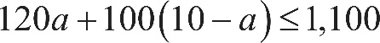 120 a, plus 100, times, open parenthesis, 10 minus a, close parenthesis, is less than or equal to 1,100. Using the distributive property to rewrite this inequality yields 120 a, plus 1,000, minus 100 a, is less than or equal to 1,100, or 20 a, plus 1,000, is less than or equal to 1,100. Subtracting 1,000 from both sides of this inequality yields 20 a, is less than or equal to 100. Dividing both sides of this inequality by 20 results in a, is less than or equal to 5. This means that the maximum number of 120-pound packages that the helicopter can carry per trip is 5.
Incorrect answer
Choices A, B, and D are incorrect and may result from incorrectly creating or solving the system of inequalities.

Explanation for question 14.
Correct answer
Choice B is correct. The difference between the machine’s starting value and its value after 10 years can be found by subtracting $30,000 from $120,000: 120,000 minus 30,000, equals 90,000. It’s given that the value of the machine depreciates by the same amount each year for 10 years. Dividing $90,000 by 10 gives $9,000, which is the amount by which the value depreciates each year. Therefore, over a period of t years, the value of the machine depreciates by a total of 9,000 t dollars. The value v of the machine, in dollars, t years after it was purchased is the starting value minus the amount of depreciation after t years, or 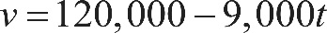 v equals, 120,000 minus 9,000 t.
Incorrect answer
Choice A is incorrect and may result from using the value of the machine after 10 years as the machine’s starting value. Choice C is incorrect. This equation shows the amount the machine’s value changes each year being added to, rather than subtracted from, the starting value. Choice D is incorrect and may result from multiplying the machine’s value after 10 years by t instead of multiplying the amount the machine depreciates each year by t.

Explanation for question 15.
Correct answer
Choice D is correct. The slope-intercept form of a linear equation is 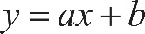 y equals, a, x plus b, where a is the slope of the graph of the equation and b is the y-coordinate of the y-intercept of the graph. Two ordered pairs 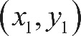 x sub 1 comma y sub 1 and 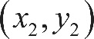 x sub 2 comma y sub 2 can be used to compute the slope of the line with the formula 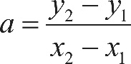 a, equals, the fraction with numerator y sub 2 minus y sub 1, and denominator x sub 2 minus x sub 1, end fraction. Substituting the two ordered pairs 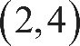 2 comma 4 and 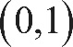 0 comma 1 into this formula gives 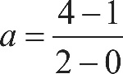 a, equals, the fraction with numerator 4 minus 1, and denominator 2 minus 0, end fraction, which simplifies to three halves. Substituting this value for a in the slope-intercept form of the equation yields 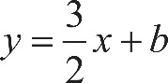 y equals, three halves x, plus b. Substituting values from the ordered pair 0 comma 1 into this equation yields 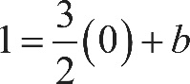 1 equals, three halves times 0, plus b, so b equals 1. Substituting this value for b in the slope-intercept equation yields 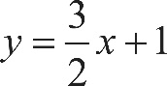 y equals, three halves x, plus 1.
Incorrect answer
Choice A is incorrect. This may result from misinterpreting the change in x-values as the slope and misinterpreting the change in y-values as the y-coordinate of the y-intercept of the graph. Choice B is incorrect and may result from using the x- and y-values of one of the given points as the slope and y-coordinate of the y-intercept, respectively. Choice C is incorrect. This equation has the correct slope but the incorrect y-coordinate of the y-intercept.

Explanation for question 16.
Correct answer
Choice B is correct. Multiplying the binomials in the given expression results in 4 a, x squared, plus 4 a, x, minus 4 x, minus 4, minus x squared, plus 4. Combining like terms yields 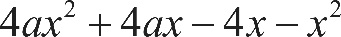 4 a, x squared, plus 4 a, x, minus 4 x, minus x squared. Grouping by powers of x and factoring out their greatest common factors yields 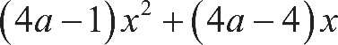 open parenthesis, 4 a, minus 1, close parenthesis, times x squared, plus, open parenthesis, 4 a, minus 4, close parenthesis, times x. It’s given that this expression is equivalent to b x, so 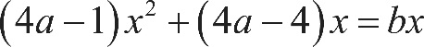 open parenthesis, 4 a, minus 1, close parenthesis, times x squared, plus, open parenthesis, 4 a, minus 4, close parenthesis, times x, equals b x. Since the right-hand side of the equation has no 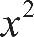 x squared term, the coefficient of the x squared term on the left-hand side must be 0. This gives 4 a, minus 1, equals 0 and 4 a, minus 4, equals b. Since 4 a, minus 1, equals 0, 4 a, equals 1. Substituting the value of 4 a into the second equation gives 1 minus 4, equals b, so b equals, negative 3.
Incorrect answer
Choices A, C, and D are incorrect and may result from a calculation error.

Explanation for question 17.
Correct answer
Choice C is correct. Multiplying both sides of 2 w plus 4, t, equals 14 by 2 yields 4 w plus 8, t, equals 28. Subtracting the second given equation from 4 w plus 8, t, equals 28 yields open parenthesis, 4 w minus 4 w, close parenthesis, plus, open parenthesis, 8, t minus 5 t, close parenthesis, equals, open parenthesis, 28 minus 25, close parenthesis or 3 t equals 3. Dividing both sides of this equation by 3 yields t equals 1. Substituting 1 for t in the equation 2 w plus 4, t, equals, 14 yields 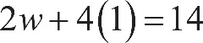 2 w plus, 4 times 1, equals 14, or 2 w plus 4, equals 14. Subtracting 4 from both sides of this equation yields 2 w equals 10, and dividing both sides of this equation by 2 yields w equals 5. Substituting 5 for w and 1 for t in the expression 2 w plus 3 t yields 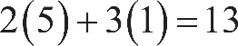 2 times 5, plus, 3 times 1, equals 13.
Incorrect answer
Choices A, B, and D are incorrect and may result from incorrectly calculating the values of w and t, or from correctly calculating the values of w and t but finding the value of an expression other than 2 w plus 3 t. For instance, choice A is the value of w plus t, choice B is the value of 2 w, and choice D is the value of 2 t plus 3 w.

Explanation for question 18.
Correct answer
Choice B is correct. It’s given that each serving of Crunchy Grain cereal provides 5% of an adult’s daily allowance of potassium, so x servings would provide x times 5%. The percentage of an adult’s daily allowance of potassium, p, is 5 times the number of servings, x. Therefore, the percentage of an adult’s daily allowance of potassium can be expressed as 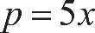 p equals 5 x.
Incorrect answer
Choices A, C, and D are incorrect and may result from incorrectly converting 5% to its decimal equivalent, which isn’t necessary since p is expressed as a percentage. Additionally, choices C and D are incorrect because the context should be represented by a linear relationship, not by an exponential relationship.

Explanation for question 19.
Correct answer
Choice B is correct. It’s given that a three fourths-cup serving of Crunchy Grain cereal provides 210 calories. The total number of calories per cup can be found by dividing 210 by three fourths, which gives 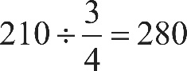 210 divided by three fourths, equals 280 calories per cup. Let c be the number of cups of Crunchy Grain cereal and s be the number of cups of Super Grain cereal. The expression 280 c represents the number of calories in c cups of Crunchy Grain cereal, and 240 s represents the number of calories in s cups of Super Grain cereal. The equation 280 c plus 240 s, equals 270 gives the total number of calories in one cup of the mixture. Since c plus s, equals 1 cup, c equals, 1 minus s. Substituting 1 minus s for c in the equation 280 c plus 240 s, equals 270 yields 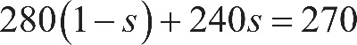 280 times, open parenthesis, 1 minus s, close parenthesis, plus 240 s, equals 270, or 280 minus 280 s, plus 240 s, equals 270. Simplifying this equation yields 280 minus 40 s, equals 270. Subtracting 280 from both sides results in negative 40 s, equals negative 10. Dividing both sides of the equation by negative 40 results in 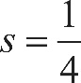 s equals one fourth, so there is one fourth cup of Super Grain cereal in one cup of the mixture.
Incorrect answer
Choices A, C, and D are incorrect and may result from incorrectly creating or solving the system of equations.

Explanation for question 20.
Correct answer
Choice A is correct. There are 0 calories in 0 servings of Crunchy Grain cereal so the line must begin at the point with coordinates 0 comma 0. Point with coordinates 0 comma 0 is the origin, labeled O. Additionally, each serving increases the calories by 250. Therefore, the number of calories increase as the number of servings increase, so the line must have a positive slope. Of the choices, only choice A shows a graph with a line that begins at the origin and has a positive slope.
Incorrect answer
Choices B, C, and D are incorrect. These graphs don’t show a line that passes through the origin. Additionally, choices C and D may result from misidentifying the slope of the graph.

Explanation for question 21.
Correct answer
Choice D is correct. Since the function h is exponential, it can be written as 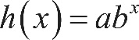 h of x equals, a, b to the x power, where a is the y-coordinate of the y-intercept and b is the growth rate. Since it’s given that the y-coordinate of the y-intercept is d, the exponential function can be written as 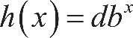 h of x equals, d b to the x power. These conditions are only met by the equation in choice D.
Incorrect answer
Choice A is incorrect. For this function, the value of 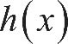 h of x when x equals 0 is negative 3, not d. Choice B is incorrect. This function is a linear function, not an exponential function. Choice C is incorrect. This function is a polynomial function, not an exponential function.

Explanation for question 22.
Correct answer
Choice B is correct. The median weight is found by ordering the horses’ weights from least to greatest and then determining the middle value from this list of weights. Decreasing the value for the horse with the lowest weight doesn’t affect the median since it’s still the lowest value.
Incorrect answer
Choice A is incorrect. The mean is calculated by finding the sum of all the weights of the horses and then dividing by the number of horses. Decreasing one of the weights would decrease the sum and therefore decrease the mean. Choice C is incorrect. Range is the difference between the highest and lowest weights, so decreasing the lowest weight would increase the range. Choice D is incorrect. Standard deviation is calculated based on the mean weight of the horses. Decreasing one of the weights decreases the mean and therefore would affect the standard deviation.

Explanation for question 23.
Correct answer
Choice B is correct. In order for the poll results from a sample of a population to represent the entire population, the sample must be representative of the population. A sample that is randomly selected from a population is more likely than a sample of this type described to represent the population. In this case, the people who responded were people with access to cable television and websites, which aren’t accessible to the entire population. Moreover, the people who responded had access and also chose to watch the show and respond to the poll. The people who made these choices aren’t representative of the entire population of the United States.
Incorrect answer
Choices A, C, and D are incorrect because they present reasons unrelated to whether the sample is representative of the population of the United States.

Explanation for question 24.
Correct answer
Choice C is correct. Substituting x plus a for x in 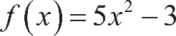 f of x equals, 5 x squared, minus 3 yields 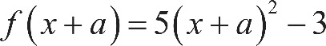 f of, open parenthesis, x plus a, close parenthesis, equals, 5 times, open parenthesis, x plus a, close parenthesis, squared, minus 3. Expanding the expression 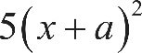 5 times, open parenthesis, x plus a, close parenthesis, squared by multiplication yields 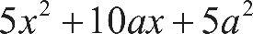 5 x squared, plus 10 a, x, plus 5 a, squared, and thus f of, open parenthesis, x plus a, close parenthesis, equals, 5 x squared, plus 10 a, x, plus 5 a, squared, minus 3. Setting the expression on the right-hand side of this equation equal to the given expression for 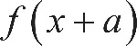 f of, open parenthesis, x plus a, close parenthesis yields 5 x squared, plus 30 x, plus 42, equals, 5 x squared, plus 10 a, x, plus 5 a, squared, minus 3. Because this equality must be true for all values of x, the coefficients of each power of x are equal. Setting the coefficients of x equal to each other gives 10 a, equals 30. Dividing each side of this equation by 10 yields a, equals 3.
Incorrect answer
Choices A, B, and D are incorrect and may result from a calculation error.

Explanation for question 25.
Correct answer
Choice C is correct. The sine of an angle is equal to the cosine of the angle’s complement. This relationship can be expressed by the equation 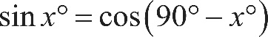 the sine of x degrees equals, the cosine of, open parenthesis, 90 degrees minus x degrees, close parenthesis. Therefore, if the sine of x degrees equals a, then 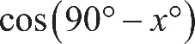 the cosine of, open parenthesis, 90 degrees minus x degrees, close parenthesis must also be equal to a.
Incorrect answer
Choices A and B are incorrect and may result from misunderstanding the relationship between the sine and cosine of complementary angles. Choice D is incorrect and may result from misinterpreting 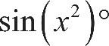 the sine of, open parenthesis, x squared, close parenthesis, degrees as 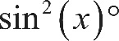 the sine squared of, open parenthesis, x, close parenthesis, degrees.

Explanation for question 26.
Correct answer
Choice D is correct. The positive x-intercept of the graph of 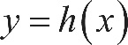 y equals, h of x is a point 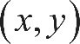 with coordinates x comma y for which 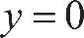 y equals 0. Since y equals, h of x models the height above the ground, in feet, of the projectile, a y-value of 0 must correspond to the height of the projectile when it is 0 feet above ground or, in other words, when the projectile is on the ground. Since x represents the time since the projectile was launched, it follows that the positive x-intercept, 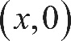 the point with coordinates x comma 0, represents the time at which the projectile hits the ground.
Incorrect answer
Choice A is incorrect and may result from misidentifying the y-intercept as a positive x-intercept. Choice B is incorrect and may result from misidentifying the y-value of the vertex of the graph of the function as an x-intercept. Choice C is incorrect and may result from misidentifying the x-value of the vertex of the graph of the function as an x-intercept.

Explanation for question 27.
Correct answer
Choice A is correct. Since 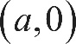 the point with coordinates a, comma 0 and 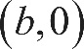 the point with coordinates b comma 0 are the only two points where the graph of f crosses the x-axis, it must be true that 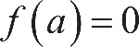 f of a, equals 0 and 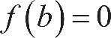 f of b, equals 0 and that 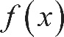 f of x is not equal to 0 for any other value of x. Of the given choices, choice A is the only function for which this is true. If 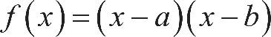 f of x equals, open parenthesis, x minus a, close parenthesis, times, open parenthesis, x minus b, close parenthesis, then 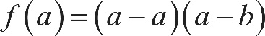 f of a, equals, open parenthesis, a, minus a, close parenthesis, times, open parenthesis, a, minus b, close parenthesis, which can be rewritten as 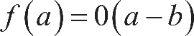 f of a, equals, 0 times, open parenthesis, a, minus b, close parenthesis, or f of a, equals 0. Also, 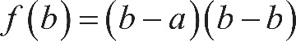 f of b equals, open parenthesis, b minus a, close parenthesis, times, open parenthesis, b minus b, close parenthesis, which can be rewritten as 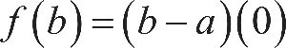 f of b equals, open parenthesis, b minus a, close parenthesis, times 0, or f of b, equals 0. Furthermore, if f of x equals, open parenthesis, x minus a, close parenthesis, times, open parenthesis, x minus b, close parenthesis is equal to 0, then it follows that either x minus a, equals 0 or x minus b, equals 0. Solving each of these equations by adding a to both sides of the first equation and adding b to both sides of the second equation yields x equals a or x equals b. Therefore, the graph of f of x equals, open parenthesis, x minus a, close parenthesis, times, open parenthesis, x minus b, close parenthesis crosses the x-axis at exactly two points, the point with coordinates a, comma 0 and the point with coordinates b comma 0.
Incorrect answer
Choice B is incorrect because 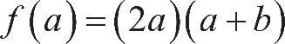 f of a, equals, 2 a, times, open parenthesis, a, plus b, close parenthesis, which can’t be 0 because it’s given that a and b are positive. Choice C is incorrect because 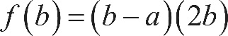 f of b equals, open parenthesis, b minus a, close parenthesis, times 2 b; its graph could only be 0 if b equals a, but it would cross the x-axis at only one point, since the point with coordinates a, comma 0 and the point with coordinates b comma 0 would be the same point. Choice D is incorrect because its graph crosses the x-axis at the point with coordinates 0 comma 0 as well as at the point with coordinates a, comma 0 and the point with coordinates b comma 0.

Explanation for question 28.
Correct answer
Choice C is correct. Substituting 0 for x in the given equation yields 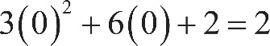 3 times, open parenthesis, 0, close parenthesis, squared, plus, 6 times 0, plus 2, equals 2. Therefore, the graph of the given equation passes through the point 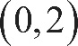 with coordinates 0 comma 2, which is the y-intercept of the graph. The right-hand side of the given equation, 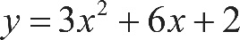 y equals, 3 x squared, plus 6 x, plus 2, displays the constant 2, which directly corresponds to the y-coordinate of the y-intercept of the graph of this equation in the x y-plane.
Incorrect answer
Choice A is incorrect. The y-coordinate of the vertex of the graph is negative 1, not 3, 6, or 2. Choice B is incorrect. The x-coordinates of the x-intercepts of the graph are at approximately negative 1.577 and negative 0.423, not 3, 6, or 2. Choice D is incorrect. The x-coordinate of the x-intercept of the line of symmetry is at negative 1, not 3, 6, or 2.

Explanation for question 29.
Correct answer
Choice A is correct. The given equation is in slope-intercept form, or 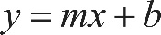 y equals, m x plus b, where m is the value of the slope of the line of best fit. Therefore, the slope of the line of best fit is 0.096. From the definition of slope, it follows that an increase of 1 in the x-value corresponds to an increase of 0.096 in the y-value. Therefore, the line of best fit predicts that for each year between 1940 and 2010, the minimum wage will increase by 0.096 dollar per hour.
Incorrect answer
Choice B is incorrect and may result from using the y-coordinate of the y-intercept as the average increase, instead of the slope. Choice C is incorrect and may result from using the 10-year increments given on the x-axis to incorrectly interpret the slope of the line of best fit. Choice D is incorrect and may result from using the y-coordinate of the y-intercept as the average increase, instead of the slope, and from using the 10-year increments given on the x-axis to incorrectly interpret the slope of the line of best fit.

Explanation for question 30.
Correct answer
Choice D is correct. On the line of best fit, d increases from approximately 480 to 880 between t equals 12 and t equals 24. The slope of the line of best fit is the difference in d-values divided by the difference in t-values, which gives 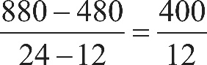 the fraction with numerator 880 minus 480, and denominator 24 minus 12, end fraction, equals, the fraction 400 over 12 or approximately 33. Writing the equation of the line of best fit in slope-intercept form gives d equals, 33 t plus b, where b is the y-coordinate of the y-intercept. This equation is satisfied by all points on the line, so d equals 480 when t equals 12. Thus, 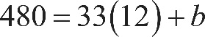 480 equals, 33 times 12, plus b, which is equivalent to 480 equals, 396 plus b. Subtracting 396 from both sides of this equation gives b equals 84. Therefore, an equation for the line of best fit could be d equals, 33 t plus 84.
Incorrect answer
Choice A is incorrect and may result from an error in calculating the slope and misidentifying the y-coordinate of the y-intercept of the graph as the value of d at t equals 10 than the value of d at t equals 0. Choice B is incorrect and may result from using the smallest value of t on the graph as the slope and misidentifying the y-coordinate of the y-intercept of the graph as the value of d at t equals 10 rather than the value of d at t equals 0. Choice C is incorrect and may result from misidentifying the y-coordinate of the y-intercept as the smallest value of d on the graph.

Explanation for question 31.
Correct answer
The correct answer is 6. Circles are symmetric with respect to any given diameter through the center 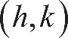 the point with coordinates h comma k. One diameter of the circle is perpendicular to the x-axis. Therefore, the value of h is the mean of the x-coordinates of the circle’s two x-intercepts: 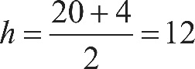 h equals, the fraction with numerator 20 plus 4, and denominator 2, which equals 12. The radius of the circle is given as 10, so the point with coordinates h comma k must be a distance of 10 units from any point on the circle. The equation of any circle can be written as 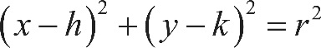 open parenthesis, x minus h, close parenthesis, squared, plus, open parenthesis, y minus k, close parenthesis, squared, equals r squared, where the point with coordinates h comma k is the center of the circle and r is the length of the radius of the circle. Substituting 12 for h and 10 for r into this equation gives 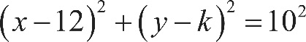 open parenthesis, x minus 12, close parenthesis, squared, plus, open parenthesis, y minus k, close parenthesis, squared, equals 10 squared. Substituting the x-coordinate and y-coordinate of a point on the circle, 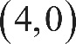 4 comma 0, gives 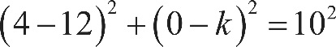 open parenthesis, 4 minus 12, close parenthesis, squared, plus, open parenthesis, 0 minus k, close parenthesis, squared, equals 10 squared, or 64 plus k squared, equals 100. Subtracting 64 from both sides of this equation yields 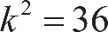 k squared equals 36. Therefore, 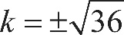 k equals, plus or minus the square root of 36. Since the graph shows the point with coordinates h comma k in the first quadrant, k must be the positive square root of 36, so k equals 6.

Explanation for question 32.
Correct answer
The correct answer is 2. It’s given that line l is perpendicular to the line with equation 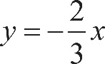 y equals, negative two thirds x. Since the equation y equals, negative two thirds x is written in slope-intercept form, the slope of the line is 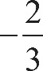 negative two thirds. The slope of line l must be the negative reciprocal of negative two thirds, which is three halves. It’s also given that the y-coordinate of the y-intercept of line l is negative 13, so the equation of line l in slope-intercept form is 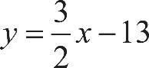 y equals, three halves x, minus 13. If 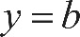 y equals b when x equals 10, 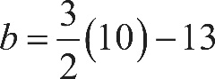 b equals, three halves times 10, minus 13, which is equivalent to b equals, 15 minus 13, or b equals 2.

Explanation for question 33.
Correct answer
The correct answer is 8. In this group, 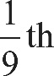 one ninth of the people who are rhesus negative have blood type B. The total number of people who are rhesus negative in the group is 7 plus 2, plus 1, plus x, and there are 2 people who are rhesus negative with blood type B. Therefore, 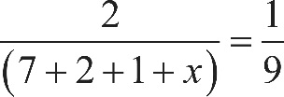 the fraction with numerator 2, and denominator, 7 plus 2, plus 1, plus x, end fraction, equals one ninth. Combining like terms on the left-hand side of the equation yields 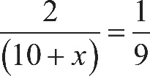 the fraction with numerator 2, and denominator, 10 plus x, end fraction, equals one ninth. Multiplying both sides of this equation by 9 yields 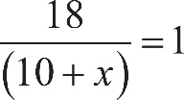 the fraction with numerator 18, and denominator, 10 plus x, end fraction, equals 1, and multiplying both sides of this equation by 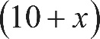 open parenthesis, 10 plus x, close parenthesis yields 18 equals, 10 plus x. Subtracting 10 from both sides of this equation yields 8 equals x.

Explanation for question 34.
Correct answer
The correct answer is 9. The median number of goals scored is found by ordering the number of goals scored from least to greatest and then determining the middle value in the list. If the number of goals scored in each of the 29 games were listed in order from least to greatest, the median would be the fifteenth number of goals. The graph shows there were 8 games with 1 goal scored and 9 games with 2 goals scored. Therefore, the fifteenth number, or the median number, of goals scored must be 2. According to the graph, the soccer team scored 2 goals in 9 of the games played.

Explanation for question 35.
Correct answer
The correct answer is 15. It’s given that the deductions reduce the original amount of taxes owed by $2,325.00. Since the deductions reduce the original amount of taxes owed by d %, the equation 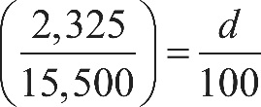 2,325, over 15,500, equals, d over 100 can be used to find this percent decrease, d. Multiplying both sides of this equation by 100 yields 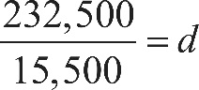 232,500 over 15,500, equals d, or 15 equals d. Thus, the tax deductions reduce the original amount of taxes owed by 15%.

Explanation for question 36.
Correct answer
The correct answer is 1.5. It’s given that the system of linear equations has no solutions. Therefore, the lines represented by the two equations are parallel. Each of the equations can be written in slope-intercept form, or y equals, m x plus b, where m is the slope of the line and b is the y-coordinate of the line’s y-intercept. Subtracting 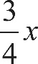 three fourths x from both sides of 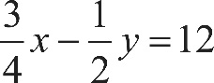 three fourths x, minus one half y, equals 12 yields 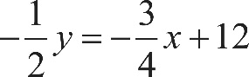 negative one half y, equals negative three fourths x, plus 12. Dividing both sides of this equation by 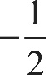 negative one half yields 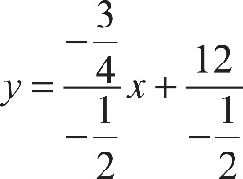 y equals, the fraction with numerator negative three fourths, and denominator negative one half, end fraction, times x, plus, the fraction with numerator 12, and denominator negative one half, end fraction, or 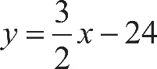 y equals, three halves x, minus 24. Therefore, the slope of the line represented by the first equation in the system is three halves. The second equation in the system can be put into slope-intercept form by first subtracting a x from both sides of 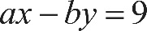 a, x minus b y, equals 9, then dividing both sides of the equation by negative b, which yields 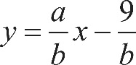 y equals, the fraction a, over b, end fraction, times x, minus, the fraction 9 over b. Therefore, the slope of the line represented by the second equation in the system is a, over b. Parallel lines have equal slopes. Therefore, 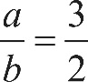 a, over b, equals three halves. Either 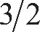 3 slash 2 or 1.5 may be entered as the correct answer.

Explanation for question 37.
Correct answer
The correct answer is 1.3. The median number of tourists is found by ordering the number of tourists from least to greatest and determining the middle value from this list. When the number of tourists in 2012 is ordered from least to greatest, the middle value, or the fifth number, is 46.4 million. When the number of tourists in 2013 is ordered from least to greatest, the middle value, or the fifth number, is 47.7 million. The difference between these two medians is 47.7 million minus 46.4 million, equals 1.3 million.

Explanation for question 38.
Correct answer
The correct answer is 3. Let y be the number of international tourist arrivals in Russia in 2012, and let x be the number of these arrivals in 2011. It’s given that y is 13.5% greater than x, or 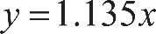 y equals, 1.135 x. The table gives that 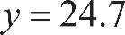 y equals 24.7, so 24.7 equals, 1.135 x. Dividing both sides of this equation by 1.135 yields 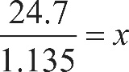 24.7 over 1.135, equals x, or x is approximately equal to 21.8 million arrivals. The difference in the number of tourist arrivals between these two years is 24.7 million minus 21.8 million, equals 2.9 million. Therefore, the value of k is 3 when rounded to the nearest integer.

