The S A T®
Assistive Technology Compatible Test Form

Practice Test 9

Answers and explanations for section 3, Math Test—No Calculator

Explanation for question 1.
Correct answer
Choice B is correct. Multiplying both sides of the first equation in the system by 2 yields 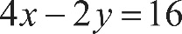 4 x minus 2 y, equals 16. Adding 4 x minus 2 y, equals 16 to the second equation in the system yields 5 x equals 20. Dividing both sides of 5 x equals 20 by 5 yields x equals 4. Substituting 4 for x in 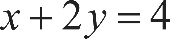 x plus 2 y, equals 4 yields 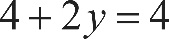 4 plus 2 y, equals 4. Subtracting 4 from both sides of 4 plus 2 y, equals 4 yields 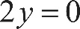 2 y equals 0. Dividing both sides of this equation by 2 yields 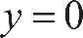 y equals 0. Substituting 4 for x and 0 for y in the expression x plus y yields 4 plus 0, equals 4.
Incorrect answer
Choices A, C, and D are incorrect and may result from various computation errors.

Explanation for question 2.
Correct answer
Choice A is correct. Since 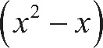 open parenthesis, x squared, minus x, close parenthesis is a common term in the original expression, like terms can be added: 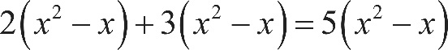 2 times, open parenthesis, x squared, minus x, close parenthesis, plus, 3 times, open parenthesis, x squared, minus x, close parenthesis, equals, 5 times, open parenthesis, x squared, minus x, close parenthesis. Distributing the constant term 5 yields 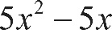 5 x squared, minus 5 x.
Incorrect answer
Choice B is incorrect and may result from not distributing the negative signs in the expressions within the parentheses. Choice C is incorrect and may result from not distributing the negative signs in the expressions within the parentheses and from incorrectly eliminating the 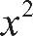 x squared-term. Choice D is incorrect and may result from incorrectly eliminating the x-term.

Explanation for question 3.
Correct answer
Choice D is correct. To find the slope and y-intercept, the given equation can be rewritten in slope-intercept form 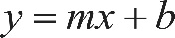 y equals, m x plus b, where m represents the slope of the line and b represents the y-intercept. The given equation 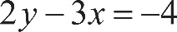 2 y minus 3 x, equals negative 4 can be rewritten in slope-intercept form by first adding 3 x to both sides of the equation, which yields 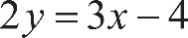 2 y equals, 3 x minus 4. Then, dividing both sides of the equation by 2 results in the equation 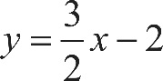 y equals, three halves x, minus 2. The coefficient of x, three halves, is the slope of the graph and is positive, and the constant term, negative 2, is the y-intercept of the graph and is negative. Thus, the graph of the equation 2 y minus 3 x, equals negative 4 has a positive slope and a negative y-intercept.
Incorrect answer
Choice A is incorrect and may result from reversing the values of the slope and the y-intercept. Choices B and C are incorrect and may result from errors in calculation when determining the slope and y-intercept values.

Explanation for question 4.
Correct answer
Choice A is correct. It’s given that the front of the roller-coaster car starts rising when it’s 15 feet above the ground. This initial height of 15 feet can be represented by a constant term, 15, in an equation. Each second, the front of the roller-coaster car rises 8 feet, which can be represented by 8 s. Thus, the equation h equals, 8 s plus 15 gives the height, in feet, of the front of the roller-coaster car s seconds after it starts up the hill.
Incorrect answer
Choices B and C are incorrect and may result from conceptual errors in creating a linear equation. Choice D is incorrect and may result from switching the rate at which the roller-coaster car rises with its initial height.

Explanation for question 5.
Correct answer
Choice C is correct. Since the variable h represents the number of hours a job took, the coefficient of h, 75, represents the electrician’s charge per hour, in dollars, after an initial fixed charge of $125. It’s given that the electrician worked 2 hours longer on Ms. Sanchez’s job than on Mr. Roland’s job; therefore, the additional charge for Ms. Sanchez’s job is 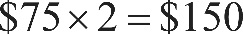 $75 times 2, equals $150.

Alternate approach: The amounts the electrician charged for Mr. Roland’s job and Ms. Sanchez’s job can be expressed in terms of t. If Mr. Roland’s job took t hours, then it cost 75 t plus 125 dollars. Ms. Sanchez’s job must then have taken t plus 2 hours, so it cost 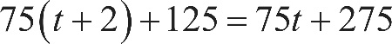 75 times, open parenthesis, t plus 2, close parenthesis, plus 125, equals, 75 t plus 275 dollars. The difference between the two costs is open parenthesis, 75 t plus 275, close parenthesis, minus, open parenthesis, 75 t plus 125, close parenthesis, equals $150.
Incorrect answer
Choice A is incorrect. This is the electrician’s charge per hour, not the difference between what Ms. Sanchez was charged and what Mr. Roland was charged. Choice B is incorrect. This is the fixed charge for each job, not the difference between the two. Choice D is incorrect and may result from finding the total charge for a 2-hour job.

Explanation for question 6.
Correct answer
Choice B is correct. The ratio of the lengths of two arcs of a circle is equal to the ratio of the measures of the central angles that subtend the arcs. It’s given that arc A D C is subtended by a central angle with measure 100 degrees. Since the sum of the measures of the angles about a point is 360 degrees, it follows that arc A B C is subtended by a central angle with measure 360 degrees minus 100 degrees, equals 260 degrees. If s is the length of arc A B C, then s must satisfy the ratio 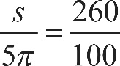 the fraction s over 5 pi, end fraction, equals, the fraction 260 over 100. Reducing the fraction 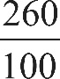 260 over 100 to its simplest form gives 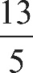 the fraction 13 over 5. Therefore, 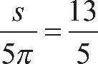 the fraction s over 5 pi, end fraction, equals, the fraction 13 over 5. Multiplying both sides of the fraction s over 5 pi, end fraction, equals, the fraction 13 over 5 by 5 pi yields s equals 13 pi.
Incorrect answer
Choice A is incorrect. This is the length of an arc consisting of exactly half of the circle, but arc A B C is greater than half of the circle. Choice C is incorrect. This is the total circumference of the circle. Choice D is incorrect. This is half the length of arc A B C, not its full length.

Explanation for question 7.
Correct answer
Choice D is correct. Multiplying both sides of the given equation by x yields 160 x equals 8. Dividing both sides of the equation 160 x equals 8 by 160 results in 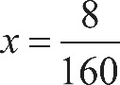 x equals, 8 over 160. Reducing 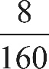 8 over 160 to its simplest form gives 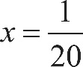 x equals, 1 over 20, or its decimal equivalent 0.05.
Incorrect answer
Choice A is incorrect and may result from multiplying, instead of dividing, the left-hand side of the given equation by 160. Choice B is incorrect and may result from a computational error. Choice C is incorrect. This is the value of 1 over x.

Explanation for question 8.
Correct answer
Choice C is correct. Applying the distributive property of multiplication to the right-hand side of the given equation gives 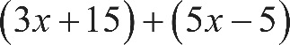 open parenthesis, 3 x plus 15, close parenthesis, plus, open parenthesis, 5 x minus 5, close parenthesis, or 8 x plus 10. An equation in the form c x plus d, equals, r x plus s will have no solutions if c equals r and d is not equal to s. Therefore, it follows that the equation 2 a, x minus 15, equals, 8 x plus 10 will have no solutions if 2 a, equals 8, or a, equals 4.
Incorrect answer
Choice A is incorrect. If a, equals 1, then the given equation could be written as 2 x minus 15, equals, 8 x plus 10. Since 2 is not equal to 8, this equation has exactly one solution. Choice B is incorrect. If a, equals 2, then the given equation could be written as 4 x minus 15, equals, 8 x plus 10. Since 4 is not equal to 8, this equation has exactly one solution. Choice D is incorrect. If a, equals 8, then the given equation could be written as 16 x minus 15, equals, 8 x plus 10. Since 16 is not equal to 8, this equation has exactly one solution.

Explanation for question 9.
Correct answer
Choice B is correct. A solution to the system of three equations is any ordered pair 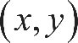 x comma y that is a solution to each of the three equations. Such an ordered pair x comma y must lie on the graph of each equation in the x y-plane; in other words, it must be a point where all three graphs intersect. The graphs of all three equations intersect at exactly one point, 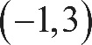 with coordinates negative 1 comma 3. Therefore, the system of equations has one solution.
Incorrect answer
Choice A is incorrect. A system of equations has no solutions when there is no point at which all the graphs intersect. Because the graphs of all three equations intersect at the point with coordinates negative 1 comma 3, there is a solution. Choice C is incorrect. The graphs of all three equations intersect at only one point, with coordinates negative 1 comma 3. Since there is no other such point, there cannot be two solutions. Choice D is incorrect and may result from counting the number of points of intersection of the graphs of any two equations, including the point of intersection of all three equations.

Explanation for question 10.
Correct answer
Choice C is correct. If the equation is true for all x, then the expressions on both sides of the equation will be equivalent. Multiplying the polynomials on the left-hand side of the equation gives 5 a, x cubed, minus a, b x squared, plus 4 a, x, plus 15 x squared, minus 3 b x, plus 12. On the right-hand side of the equation, the only x squared-term is 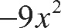 negative 9 x squared. Since the expressions on both sides of the equation are equivalent, it follows that 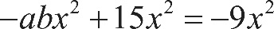 negative a, b x squared, plus 15 x squared, equals negative 9 x squared, which can be rewritten as 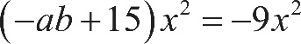 open parenthesis, negative a, b plus 15, close parenthesis, times x squared, equals negative 9 x squared. Therefore, negative a, b plus 15, equals negative 9, which gives a, b equals 24.
Incorrect answer
Choice A is incorrect. If a, b equals 18, then the coefficient of x squared on the left-hand side of the equation would be negative 18 plus 15, equals negative 3, which doesn’t equal the coefficient of x squared, negative 9, on the right-hand side. Choice B is incorrect. If a, b equals 20, then the coefficient of x squared on the left-hand side of the equation would be negative 20 plus 15, equals negative 5, which doesn’t equal the coefficient of x squared, negative 9, on the right-hand side. Choice D is incorrect. If a, b equals 40, then the coefficient of x squared on the left-hand side of the equation would be negative 40 plus 15, equals negative 25, which doesn’t equal the coefficient of x squared, negative 9, on the right-hand side.

Explanation for question 11.
Correct answer
Choice B is correct. The right-hand side of the given equation, 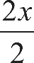 the fraction 2 x over 2, can be rewritten as x. Multiplying both sides of the equation 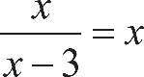 the fraction with numerator x, and denominator x minus 3, end fraction, equals x by x minus 3 yields 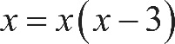 x equals, x times, open parenthesis, x minus 3, close parenthesis Applying the distributive property of multiplication to the right-hand side of the equation x equals, x times, open parenthesis, x minus 3, close parenthesis yields 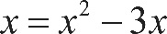 x equals, x squared, minus 3 x. Subtracting x from both sides of this equation yields 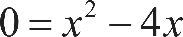 0 equals, x squared, minus 4 x. Factoring x from both terms of x squared, minus 4 x yields 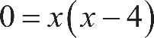 0 equals, x times, open parenthesis, x minus 4, close parenthesis. By the zero product property, the solutions to the equation 0 equals, x times, open parenthesis, x minus 4, close parenthesis are x equals 0 and x minus 4, equals 0, or x equals 4. Substituting 0 and 4 for x in the given equation yields 0 equals 0 and 4 equals 4, respectively. Since both are true statements, both 0 and 4 are solutions to the given equation.
Incorrect answer
Choice A is incorrect and may result from a sign error. Choice C is incorrect and may result from an error in factoring. Choice D is incorrect and may result from not considering 0 as a possible solution.

Explanation for question 12.
Correct answer
Choice D is correct. The original expression can be combined into one rational expression by multiplying the numerator and denominator of the second term by the denominator of the first term: 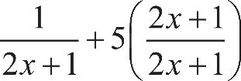 the fraction with numerator 1, and denominator 2 x plus 1, end fraction, plus, 5 times, open parenthesis, the fraction with numerator 2 x plus 1, and denominator 2 x plus 1, end fraction, close parenthesis, which can be rewritten as 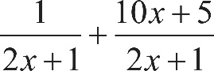 the fraction with numerator 1, and denominator 2 x plus 1, end fraction, plus, the fraction with numerator 10 x plus 5, and denominator 2 x plus 1, end fraction. This expression is now the sum of two rational expressions with a common denominator, and it can be rewritten as 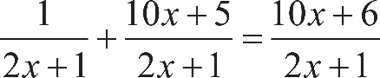 the fraction with numerator 1, and denominator 2 x plus 1, end fraction, plus, the fraction with numerator 10 x plus 5, and denominator 2 x plus 1, end fraction, equals, the fraction with numerator 10 x plus 6, and denominator 2 x plus 1, end fraction.
Incorrect answer
Choice A is incorrect and may result from a calculation error. Choice B is incorrect and may be the result of adding the denominator of the first term to the second term rather than multiplying the first term by the numerator and denominator of the second term. Choice C is incorrect and may result from not adding the numerator of 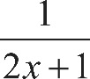 the fraction 1 over 2 x plus 1, end fraction to the numerator of 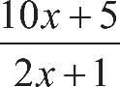 the fraction with numerator 10 x plus 5, and denominator 2 x plus 1, end fraction.

Explanation for question 13.
Correct answer
Choice A is correct. The equation of a parabola in vertex form is 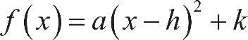 f of x equals, a, times, open parenthesis, x minus h, close parenthesis, squared, plus k, where the point 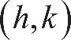 with coordinates h comma k is the vertex of the parabola and a is a constant. The graph shows that the coordinates of the vertex are 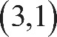 3 comma 1, so h equals 3 and k equals 1. Therefore, an equation that defines f can be written as 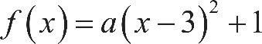 f of x equals, a, times, open parenthesis, x minus 3, close parenthesis, squared, plus 1. To find a, substitute a value for x and its corresponding value for y, or 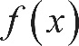 f of x. For example, 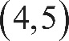 4 comma 5 is a point on the graph of f. So a must satisfy the equation 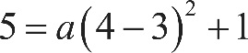 5 equals, a, times, open parenthesis, 4 minus 3, close parenthesis, squared, plus 1, which can be rewritten as 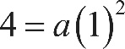 4 equals, a, times, open parenthesis, 1, close parenthesis, squared, or a, equals 4. An equation that defines f is therefore 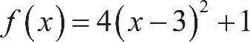 f of x equals, 4 times, open parenthesis, x minus 3, close parenthesis, squared, plus 1.
Incorrect answer
Choice B is incorrect and may result from a sign error when writing the equation of the parabola in vertex form. Choice C is incorrect and may result from omitting the constant a from the vertex form of the equation of the parabola. Choice D is incorrect and may result from a sign error when writing the equation of the parabola in vertex form as well as by miscalculating the value of a.

Explanation for question 14.
Correct answer
Choice B is correct. The solutions of the first inequality, 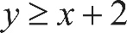 y is greater than or equal to, x plus 2, lie on or above the line 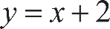 y equals, x plus 2, which is the line that passes through 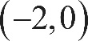 the point with coordinates negative 2 comma 0 and 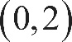 the point with coordinates 0 comma 2. The second inequality can be rewritten in slope-intercept form by dividing the second inequality, 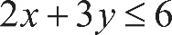 2 x plus 3 y, is less than or equal to 6, by 3 on both sides, which yields 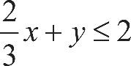 two thirds x, plus y, is less than or equal to 2, and then subtracting 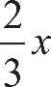 two thirds x from both sides, which yields 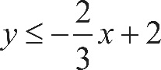 y is less than or equal to, negative two thirds x, plus 2. The solutions to this inequality lie on or below the line 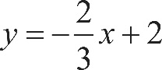 y equals, negative two thirds x, plus 2, which is the line that passes through the point with coordinates 0 comma 2 and 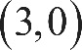 the point with coordinates 3 comma 0. The only graph in which the shaded region meets these criteria is choice B.
Incorrect answer
Choice A is incorrect and may result from reversing the inequality sign in the first inequality. Choice C is incorrect and may result from reversing the inequality sign in the second inequality. Choice D is incorrect and may result from reversing the inequality signs in both inequalities.

Explanation for question 15.
Correct answer
Choice B is correct. Squaring both sides of the given equation yields 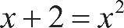 x plus 2, equals x squared. Subtracting x and 2 from both sides of x plus 2, equals x squared yields 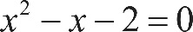 x squared, minus x, minus 2, equals 0. Factoring the left-hand side of this equation yields 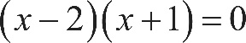 open parenthesis, x minus 2, close parenthesis, times, open parenthesis, x plus 1, close parenthesis, equals 0. Applying the zero product property, the solutions to open parenthesis, x minus 2, close parenthesis, times, open parenthesis, x plus 1, close parenthesis, equals 0 are x minus 2, equals 0, or x equals 2 and x plus 1, equals 0, or x equals negative 1. Substituting x equals 2 in the given equation gives 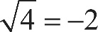 the square root of 4, equals negative 2, which is false because 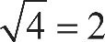 the square root of 4, equals 2 by the definition of a principal square root.

So, x equals 2 isn’t a solution. Substituting x equals negative 1 into the given equation gives 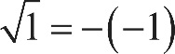 the square root of 1 equals, the negative of, negative 1, which is true because 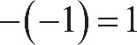 the negative of, negative 1, equals 1. So x equals negative 1 is the only solution.
Incorrect answer
Choices A and C are incorrect. The square root symbol represents the principal, or nonnegative, square root. Therefore, in the equation 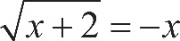 the square root of, x plus 2, end root, equals negative x, the value of negative x must be zero or positive. If x equals 2, then negative x equals negative 2, which is negative, so 2 can’t be in the set of solutions. Choice D is incorrect and may result from incorrectly reasoning that negative x always has a negative value and therefore can’t be equal to a value of a principal square root, which cannot be negative.

Explanation for question 16.
Correct answer
The correct answer is 360. The volume of a right rectangular prism is calculated by multiplying its dimensions: length, width, and height. Multiplying the values given for these dimensions yields a volume of 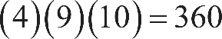 4 times 9, times 10, equals 360 cubic centimeters.

Explanation for question 17.
Correct answer
The correct answer is 2. The left-hand side of the given equation contains a common factor of 2 and can be rewritten as 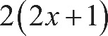 2 times, open parenthesis, 2 x plus 1, close parenthesis. Dividing both sides of this equation by 2 yields 2 x plus 1, equals 2. Therefore, the value of 2 x plus 1 is 2.

Alternate approach: Subtracting 2 from both sides of the given equation yields 4 x equals 2. Dividing both sides of this equation by 4 gives 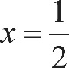 x equals one half. Substituting one half for x in the expression 2 x plus 1 yields 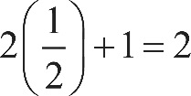 2 times one half, plus 1, equals 2.

Explanation for question 18.
Correct answer
The correct answer is 8. The graph shows that the maximum value of f of x is 2. Since 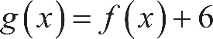 g of x equals, f of x, plus 6, the graph of g is the graph of f shifted up by 6 units. Therefore, the maximum value of 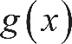 g of x is 2 plus 6, equals 8.

Explanation for question 19.
Correct answer
The correct answer is three fourths, or .75. By definition of the sine ratio, since 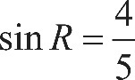 the sine of R equals four fifths, 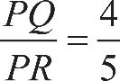 the length of side P Q over the length of side P R, equals four fifths. Therefore, if 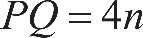 the length of side P Q equals 4 n, then the length of side P R equals 5 n, where n is a positive constant. Then 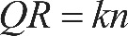 the length of side Q R equals k n, where k is another positive constant. Applying the Pythagorean theorem, the following relationship holds: 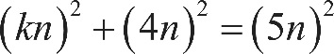 open parenthesis, k n, close parenthesis, squared, plus, open parenthesis, 4 n, close parenthesis, squared, equals, open parenthesis, 5 n, close parenthesis, squared, or 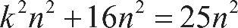 k squared n squared, plus 16 n squared, equals 25 n squared. Subtracting 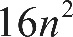 16 n squared from both sides of this equation yields 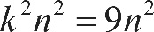 k squared n squared, equals 9 n squared. Taking the square root of both sides of k squared n squared, equals 9 n squared yields k n equals 3 n. It follows that k equals 3. Therefore, if the length of side P Q equals 4 n and the length of side P R equals 5 n, then 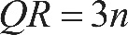 the length of side Q R equals 3 n, and by definition of the tangent ratio, 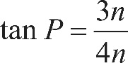 the tangent of P equals, the fraction 3 n over 4 n, end fraction, or three fourths. Either 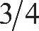 3 slash 4 or .75 may be entered as the correct answer.

Explanation for question 20.
Correct answer
The correct answer is 2.5. The graph of the linear function f passes through the points 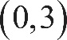 with coordinates 0 comma 3 and 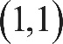 1 comma 1. The slope of the graph of the function f is therefore 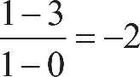 the fraction with numerator 1 minus 3, and denominator 1 minus 0, end fraction, equals negative 2. It’s given that the graph of the linear function g is perpendicular to the graph of the function f. Therefore, the slope of the graph of the function g is the negative reciprocal of negative 2, which is 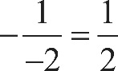 the negative of the fraction, 1 over negative 2, equals one half, and an equation that defines the function g is 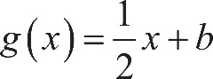 g of x equals, one half x, plus b, where b is a constant. Since it’s given that the graph of the function g passes through the point 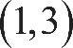 with coordinates 1 comma 3, the value of b can be found using the equation 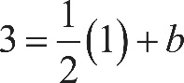 3 equals, one half times 1, plus b. Solving this equation for b yields 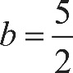 b equals five halves, so an equation that defines the function g is 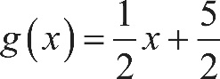 g of x equals, one half x, plus five halves. Finding the value of 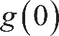 g of 0 by substituting 0 for x into this equation yields 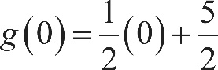 g of 0 equals, one half times 0, plus five halves, or five halves. Either 2.5 or 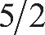 5 slash 2 may be entered as the correct answer.

